**PROGRAM 1-(a) Date:09-04-2022**

**AIM:** **Demonstrate all the basic tags in html file for formatting tags**.

**SOURCE CODE:**

<!DOCTYPE html>

<html>

<head>

<title>Formatting tags</title>

</head>

<body>

<h2>FORMATING TAGS</h2>

<h4>There are mainly 2 types of tags in html</h4>

<h1>physical tags</h1>

<i>Bapatla Engineering College</i><br>

<b>Bapatla Engineering College</b><br>

<big>Bapatla Engineering College</big><br>

<small>Bapatla Engineering College</small><br>

<u>Bapatla Engineering College</u><br>

bec<sub>Bapatla Engineering College</sub><br>

bec<sub>Bapatla Engineering College</sub>

<h1>logical tags</h1>

<p><abbr title="Bapatla Engineering College">BEC</abbr></p>

<p><dfn title="hypertext mark language">html</dfn></p>

<p><mark>bapatla</mark>engineering college<br>

<p>cse,it,ece,<ins>cs,cs</ins></p>

<P>ece,it,cse<del>,chemical,mech</del>

<p><strong>bapatla engineering college</strong><br>

<p><bdo dir="rtr">HTML</bdo></p>

<p><bdo dir="rtl">HTML</bdo></p>

<p><q>bapatla engineering colege</q><br>

<p>There are two types of errors in java<q>compile time and run time</q></p>

<p>There is an <em>acronym</em> for hypertext markup language</p>

<p><kbd>enter</kbd>key to excute the application</p>

<code>

&lt;!DOCTYPE &gt;

</code>

<p>The <samp> substring()</samp> method returns a new string instance</p>

</body>

</html>

**OUTPUT:**

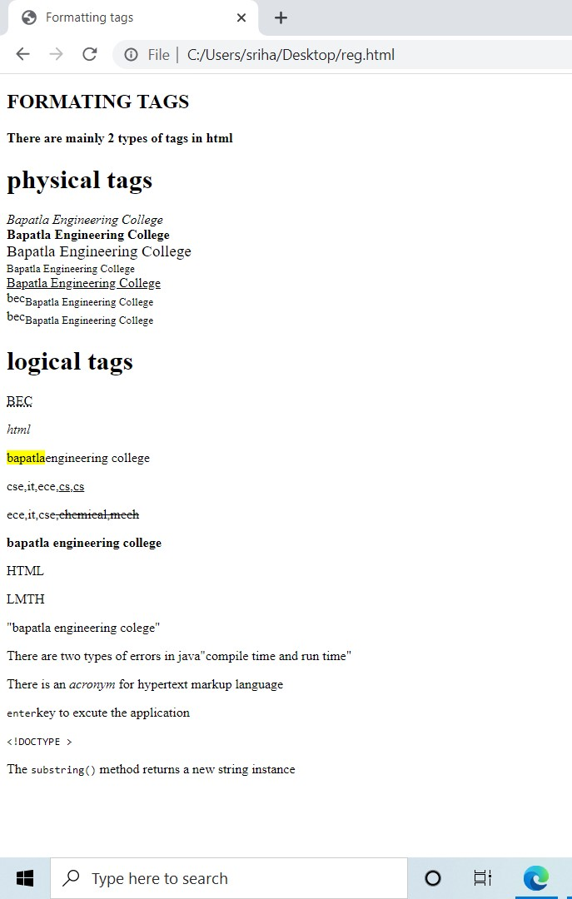

**Program-1(b) Date:09-04-2022**

**AIM:** **Demonstrate all the basic tags in html5 for representing various lists**

**SOURCE CODE:**

<!DOCTYPE html>

<html>

<body>

<h1>There are 3 types of lists in html and they are: </h1>

<h5>An unordered HTML List</h5>

<ul>

<li>coffee</li>

<li>tea</li>

<li>milk</li>

</ul>

<h2>An ordered HTML List</h2>

<ol>

<li>coffee</li>

<li>tea</li>

<li>milk</li>

</ol>

<h2> Description list</h2>

<dl>

<dt>Coffee</dt>

<dd>- black hot drink</dd>

<dt>Milk</dt>

<dd>- white cold drink</dd>

</dl>

</body>

</html>

**OUTPUT:**

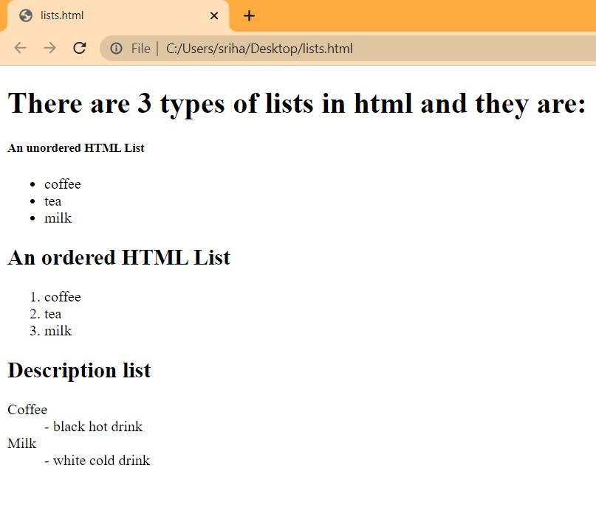

**PROGRAM-1(c) Date:16-04-2022**

**AIM:** **Demonstrate all the basic tags in html5 for timetable Creation**

**SOURCE CODE:**

<DOCTYPE! html>

<html>

<head>

<title>TIME TABLE</title>

</head>

<body style="margin-left: 20%;margin-right: 20%;border: 2px solid red;">

<div>

<div style="float: left; width: 20%;">

<img src="witoutbg.png" alt="bec logo" style="padding-left: 15%;padding-top: 15%;padding-right: 0.5%; height: 180px;">

</div>

<br>

<div style="float: right;padding-right: 2%;">

<center><h1>BAPATLA ENGINEERING COLLEGE :: BAPATLA</h1></center>

<center><h4>(Autonomous)</h4></center>

<center><h4>Department of Information Technology</h4></center>

<p style="color: red;text-align: center;">Class time table for the <u>

<span style="background-color: yellow;"> A.Y 2021-2022, IV Semester</span></u>

</p>

</div>

</div>

<div style="padding-top: 20%;padding-left: 2%;padding-right: 2%;">

<hr>

<pre>

<i> w.e.f :<strong><b style="font-size: large;">28-03-2022</b></strong> Class : <strong><b style="font-size: large;">II B.Tech, IT</b></strong> Setion :<strong><b style="font-size: large;"> A</b></strong> Room.No <strong><b style="font-size: large;">RPLH -03</b></strong></i>

</pre>

<table border="1" style="text-align: center;">

<thead>

<tr style="background-color:rgb(223, 152, 20);">

<th style="padding-left: 30px; padding-right: 30px;">

TIME &rarr;<br>DAY <b>&darr;</b>

</th>

<th style="padding:5px">5.30- <br>8.20</th>

<th style="padding:5px">8.20- <br>9.10</th>

<th style="padding:5px">9.10- <br>10.00</th>

<th style="padding:5px; background-color: rgb(223, 152, 20);" rowspan="6" >

10.00-10.30 </th>

<th style="padding:5px">10.30- <br>11.20</th>

<th style="padding:5px">11.20- <br>12.10</th>

<th style="padding:5px">12.10- <br>1.00</th>

</tr>

</thead>

<tbody>

<tr >

<td style="background-color:rgb(223, 152, 20)">MON</td>

<td style="padding-left: 30px; padding-right: 30px;">PEHV</td>

<td style="padding-left: 30px; padding-right: 30px;">DAA</td>

<td style="padding-left: 30px; padding-right: 30px;""> Python <br>Programming</td>

<td style="padding: 5px" rowspan="6"> BREAK</td>

<td style="padding: 5px">WT</td>

<td style="padding: 5px">P&S</td>

<td style="padding: 5px">DBMS</td>

</tr>

<tr>

<td style="padding: 5px;background-color:rgb(223, 152, 20)">TUE</td>

<td style="padding-left: 30px; padding-right: 30px;" colspan="3">

&larr;WT/RDBMS LAB&rarr;

</td>

<td style="padding: 5px">DBMS</td>

<td style="padding: 5px">Python <br>Programming</td>

<td style="padding: 5px">WT</td>

</tr>

<tr>

<td style="padding: 5px;background-color:rgb(223, 152, 20)">WED</td>

<td style="padding: 5px">P&S</td>

<td style="padding: 5px">DAA</td>

<td style="padding: 5px">WT</td>

<td style="padding-left: 30px; padding-right: 30px;padding-top: 3PX; padding-bottom: 3PX;" colspan="3">

&larr;RDBMS/Python Programming LAB&rarr;

</td>

</tr>

<tr>

<td style="padding: 5px;background-color:rgb(223, 152, 20)">THU</td>

<td style="padding: 5px">PEHV</td>

<td style="padding: 5px">DAA</td>

<td style="padding: 5px"> Python <br>Programming</td>

<td style="padding: 5px">WT</td>

<td style="padding: 5px">P&S</td>

<td style="padding: 5px">DBMS</td>

</tr>

<tr>

<td style="padding: 5px;background-color:rgb(223, 152, 20)">FRI</td>

<td style="padding: 5px" colspan="3">&larr;WT/RDBMS LAB&rarr;</td>

<td style="padding: 5px">DBMS</td>

<td style="padding-left: 30px; padding-right: 30px;">Python <br>Programming</td>

<td style="padding: 5px">WT</td>

</tr>

<tr>

<td style="padding: 5px;background-color:rgb(223, 152, 20)">SAT</td>

<td style="padding: 5px">PEHV</td>

<td style="padding: 5px">DAA</td>

<td style="padding: 5px"> Python <br>Programming</td>

<td style="padding-left: 30px; padding-right: 30px;">WT</td>

<td style="padding: 5px">P&S</td>

<td style="padding: 5px;background-color: greenyellow;">MENTORING</td>

</tr>

</tbody>

</table>

<p style="background-color: cyan; float: right;">

Section Coordinator : MR.K. Suresh Kumar, Asst. Professor

</p>

</div>

<div style="padding-top: 7%;padding-left: 2%;padding-right: 2%;">

<table border="1" style="text-align: center;">

<thead>

<tr style="background-color:rgb(223, 152, 20);">

<th style="padding-left: 30px; padding-right: 30px;">

TIME &rarr;<br>DAY <b>&darr;</b>

</th>

<th style="padding:5px">5.30- <br>8.20</th>

<th style="padding:5px">8.20- <br>9.10</th>

<th style="padding:5px">9.10- <br>10.00</th>

<th style="padding:5px; background-color: rgb(223, 152, 20);" rowspan="6" >

10.00-10.30

</th>

<th style="padding:5px">10.30- <br>11.20</th>

<th style="padding:5px">11.20- <br>12.10</th>

<th style="padding:5px">12.10- <br>1.00</th>

</tr>

</thead>

<tbody>

<tr >

<td style="background-color:rgb(223, 152, 20)">MON</td>

<td style="padding-left: 30px; padding-right: 30px;">PEHV</td>

<td style="padding-left: 30px; padding-right: 30px;">DAA</td>

<td style="padding-left: 30px; padding-right: 30px;""> Python <br>Programming</td>

<td style="padding: 5px" rowspan="6"> BREAK</td>

<td style="padding: 5px">WT</td>

<td style="padding: 5px">P&S</td>

<td style="padding: 5px">DBMS</td>

</tr>

<tr>

<td style="padding: 5px;background-color:rgb(223, 152, 20)">TUE</td>

<td style="padding-left: 30px; padding-right: 30px;" colspan="3">

&larr;WT/RDBMS LAB&rarr;

</td>

<td style="padding: 5px">DBMS</td>

<td style="padding: 5px">Python <br>Programming</td>

<td style="padding: 5px">WT</td>

</tr>

<tr>

<td style="padding: 5px;background-color:rgb(223, 152, 20)">WED</td>

<td style="padding: 5px">P&S</td>

<td style="padding: 5px">DAA</td>

<td style="padding: 5px">WT</td>

<td style="padding-left: 30px; padding-right: 30px;padding-top: 3PX; padding-bottom: 3PX;" colspan="3">

&larr;RDBMS/Python Programming LAB&rarr;

</td>

</tr>

<tr>

<td style="padding: 5px;background-color:rgb(223, 152, 20)">THU</td>

<td style="padding: 5px">PEHV</td>

<td style="padding: 5px">DAA</td>

<td style="padding: 5px"> Python <br>Programming</td>

<td style="padding: 5px">WT</td>

<td style="padding: 5px">P&S</td>

<td style="padding: 5px">DBMS</td>

</tr>

<tr>

<td style="padding: 5px;background-color:rgb(223, 152, 20)">FRI</td>

<td style="padding: 5px" colspan="3">&larr;WT/RDBMS LAB&rarr;</td>

<td style="padding: 5px">DBMS</td>

<td style="padding-left: 30px; padding-right: 30px;">Python <br>Programming</td>

<td style="padding: 5px">WT</td>

</tr>

<tr>

<td style="padding: 5px;background-color:rgb(223, 152, 20)">SAT</td>

<td style="padding: 5px">PEHV</td>

<td style="padding: 5px">DAA</td>

<td style="padding: 5px"> Python <br>Programming</td>

<td style="padding-left: 30px; padding-right: 30px;">WT</td>

<td style="padding: 5px">P&S</td>

<td style="padding: 5px;background-color: greenyellow;">MENTORING</td>

</tr>

</tbody>

</table>

<br><br>

<p><h3 style="float: left; padding: 50px;">H.O.D</h3><h3 style="float: right; padding: 50px;">PRINCIPAL</h3></p>

</div>

</body>

</html>

**OUTPUT:**

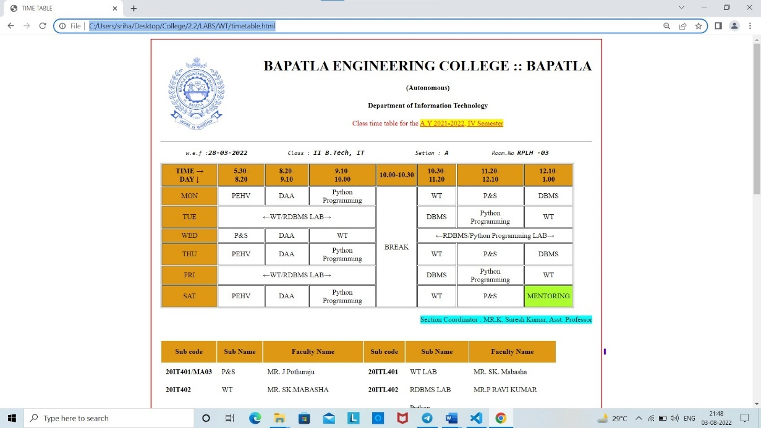

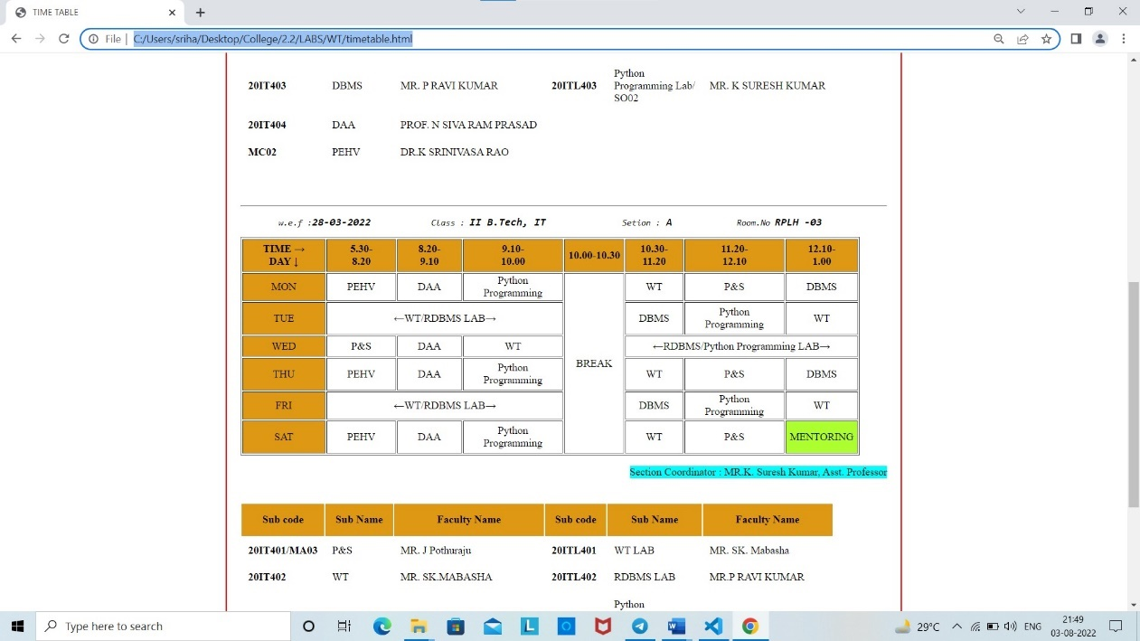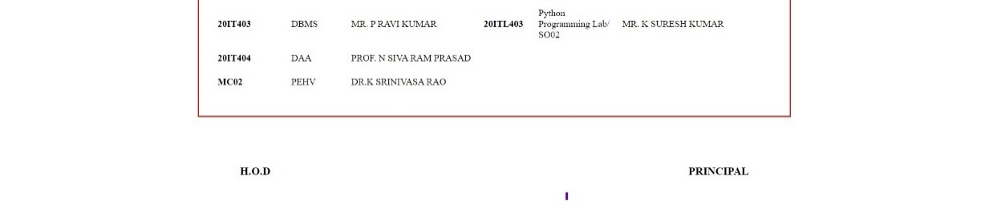

**PROGRAM-2(a) Date:23-04-2022**

**AIM: : Demonstrate all the basic tags in html5 for describing**

**internal,external and image as link.**

**SOURCE CODE:**

<!DOCTYPE html>

<html>

<body>

<title> hyper link</title>

<p>click here to open <a href="http://www.amazon.com" target="_blank">Amazon website</a></p>

<p> click here to open<a href=tags.html target="_top">details</a></p>

<p><a href="http://www.becbapatla.ac.in" target="_self"><img src="witoutbg.png" height="200" width="200"></a></p>

<a id ="top"></a>

<h1>top of the page</h1>

<a href="#bottom">click to bottom</a><br>

<a href="#middle">click to middle</a>

<p>Bapatla Engineering college </p>

<p>Bapatla Engineering college </p>

<p>Bapatla Engineering college </p>

<p>Bapatla Engineering college </p>

<p>Bapatla Engineering college </p>

<p>Bapatla Engineering college </p>

<p>Bapatla Engineering college </p>

<p>Bapatla Engineering college </p>

<p>Bapatla Engineering college </p>

<p>Bapatla Engineering college </p>

<p>Bapatla Engineering college </p>

<a id ="middle"></a>

<h1> middle of page</h1>

<a href="#top">click to top</a><br>

<a href="#bottom">click to bottom</a>

<p>Bapatla Engineering college </p>

<p>Bapatla Engineering college </p>

<p>Bapatla Engineering college </p>

<p>Bapatla Engineering college </p>

<p>Bapatla Engineering college </p>

<p>Bapatla Engineering college </p>

<p>Bapatla Engineering college </p>

<p>Bapatla Engineering college </p>

<p>Bapatla Engineering college </p>

<p>Bapatla Engineering college </p>

<p>Bapatla Engineering college </p>

<p>Bapatla Engineering college </p>

<a id ="bottom"></a>

<h1> bottom of page</h1>

<a href="#top">click to top</a><br>

<a href="#middle">click to middle</a>

</body>

</html>

**OUTPUT:**

**Web page before clicking on links:**

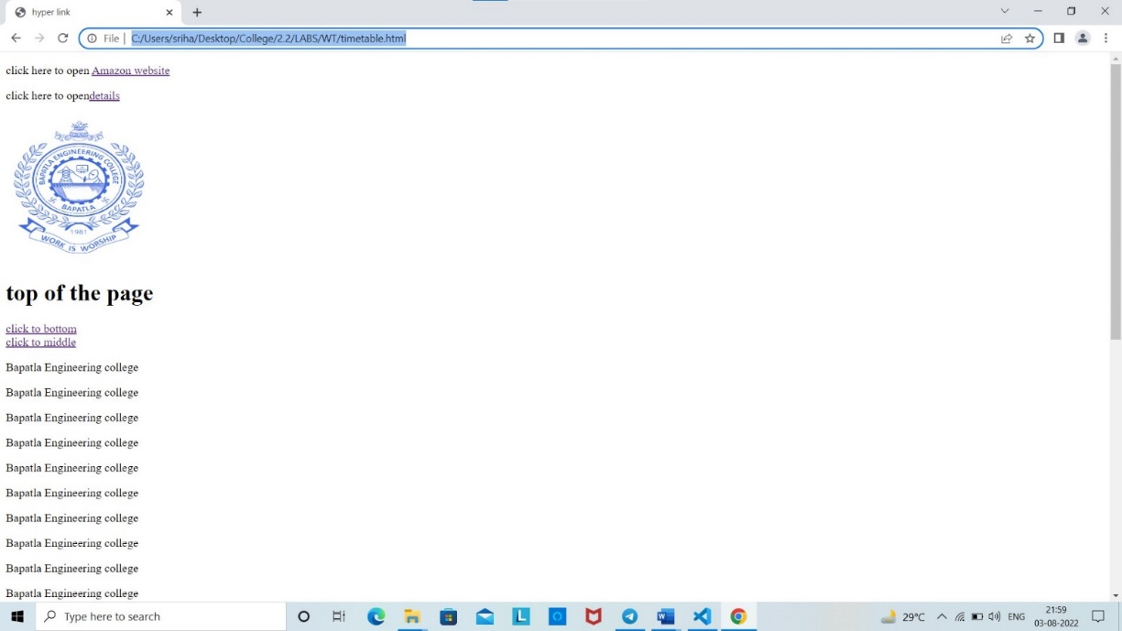

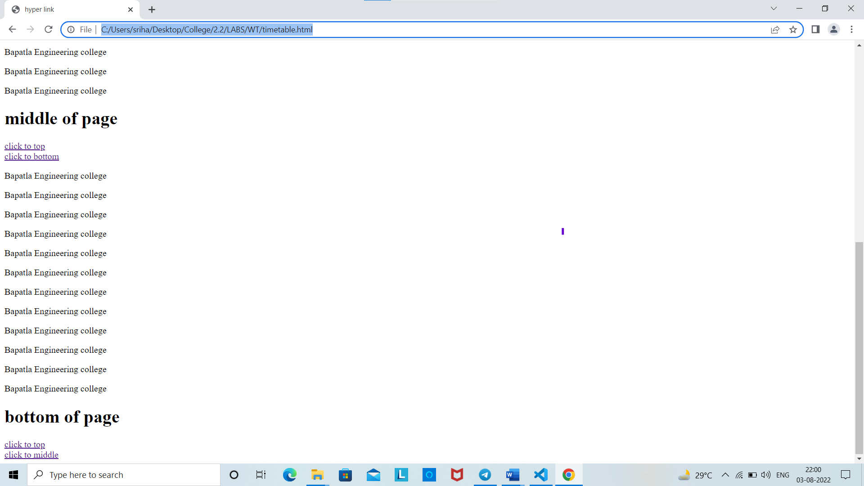

**On clicking on image as link:**

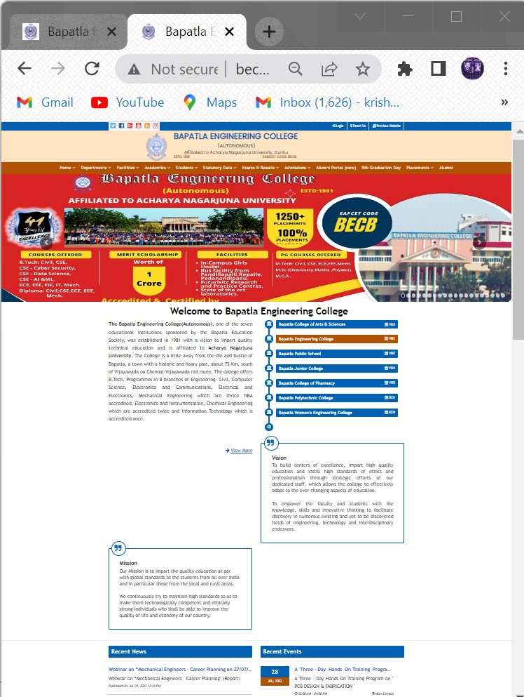

**Internal link:**



**External link:**

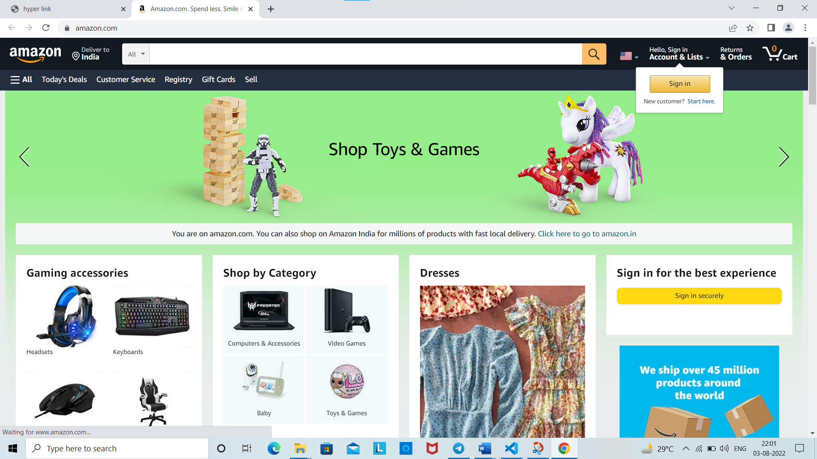

**PROGRAM-2(b) Date:30-04-2022**

**AIM:** **Design a webpage to demonstrate Id tag used in frames**

**SOURCE CODE:**

<!DOCTYPE html>

<html>

<head>

<title>frames</title>

</head>

<frameset rows="50%,25%">

<frameset cols="60%,40%">

<frame src="lists.html" name="top"></frame>

<frame src="hyperlinks.html" name="bottom left"></frame>

</frameset>

<frameset cols="50%,50%">

<frame src="lists.html" name="bottom right">

<frame <img src="image.jpg" href="http://www.becbapatla.ac.in/" > >

</frameset>

</frameset>

</html>

**lists.html file:**

<!DOCTYPE html>

<html>

<head>

<title>lists</title>

<head>

<body>

<h1> lists </h1>

<p>lists are used with &lt;ol&gt; or &lt;ul&gt; which describes the list is whether ordered or unordered</p>

<p>ordered lists of days in a week</p>

<ol>

<li>sunday</li>

<li>monday</li>

<li>tuesday</li>

<li>wednesday</li>

</ol>

</body>

</html>

**Hyperlinks.html file:**

<!DOCTYPE html>

<html>

<body>

<title> hyper link</title>

<p>click here to open <a href="http://www.amazon.com" target="_blank">Amazon website</a></p>

<p> click here to open<a href=tags.html target="_top">details</a></p>

<p><a href="http://www.becbapatla.ac.in" target="_self"><img src="bec logo.png" height="200" width="200"></a></p>

<a id ="top"></a>

<h1>top of the page</h1>

<a href="#bottom">click to bottom</a><br>

<a href="#middle">click to middle</a>

<p>Bapatla Engineering college </p>

<a id ="middle"></a>

<h1> middle of page</h1>

<a href="#top">click to top</a><br>

<a href="#bottom">click to bottom</a>

<p>Bapatla Engineering college </p>

<a id ="bottom"></a>

<h1> bottom of page</h1>

<a href="#top">click to top</a><br>

<a href="#middle">click to middle</a>

</body>

</html>

**OUTPUT:**

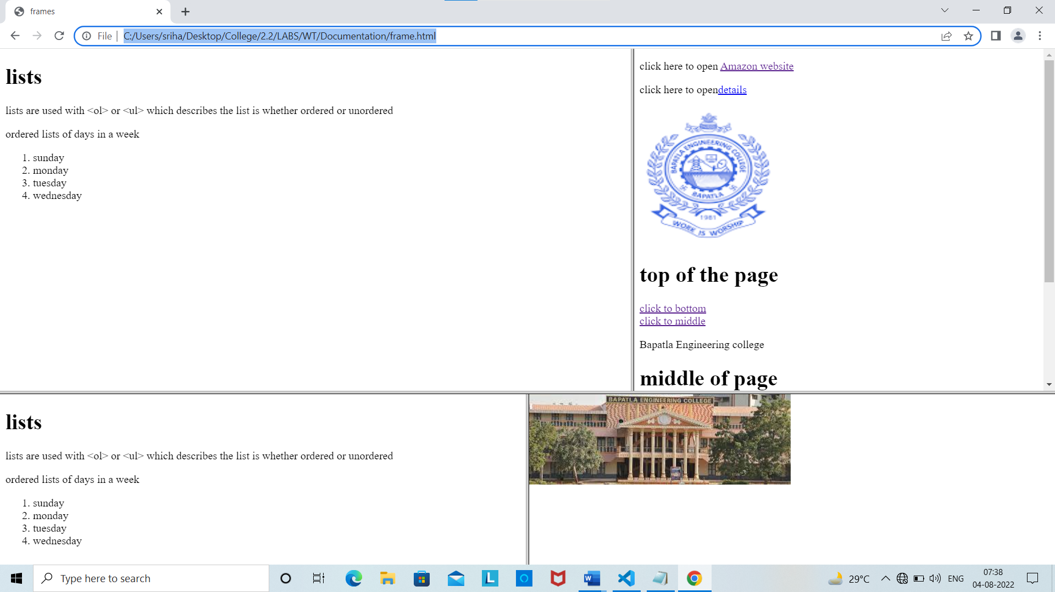

**On clicking an image in frame 2 (bec logo):**

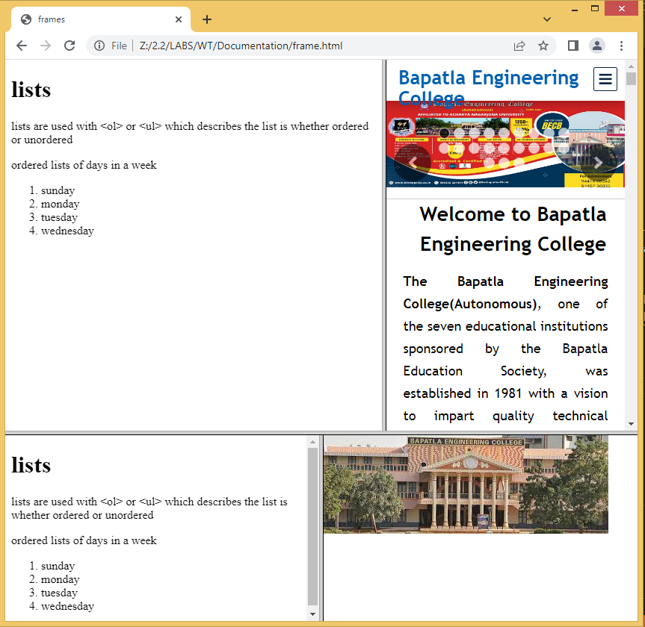

**PROGRAM-2(C) Date:30-04-2022**

**AIM:** **Demontstrate all the basic tags in html5 for Image map creation.**

**SOURCE CODE:**

<!DOCTYPE html>

<html>

<head> <title>image mapping</title> </head>

<body>

<center><h3>IMAGE mapping USING INDIA MAP</h1></center>

<hr>

<div style="margin-left:20%; margin-right: 20%; border: solid 2px cadetblue;" >

<img src="india.jpg" alt="india map" width="416" height="486" usemap="#mapp">

<h4>this is an image map where you will be redirected to the corresponding state wikipedia on clicking on the state diagram</h4>

<p>for testing or reference you can click on</p>

<pre style="font-size: large;">

1. Jammu_and_Kashmir_

2. rajasthan

3.Madhya_Pradesh

4.Uttar pradesh

</pre>

<map name="mapp">

<area shape="rect" coords="144,124,200,200" href="https://en.wikipedia.org/wiki/Uttar_Pradesh" alt="uttar pradesh">

<area shape="poly" coords="38,164,88,126,150,176,96,236" href="https://en.wikipedia.org/wiki/Rajasthan" alt="rajasthan">

<area shape="poly" coords="80,22,144,40,186,44,160,90,120,84,90,80" href="https://en.wikipedia.org/wiki/Jammu_and_Kashmir_(union_territory)" alt="Jammu_and_Kashmir_">

<area shape="poly" coords="140,190,96,260,210,224" href="https://en.wikipedia.org/wiki/Madhya_Pradesh" alt="Madhya_Pradesh">

</map>

</div>

</body>

</html>

**OUTPUT:**

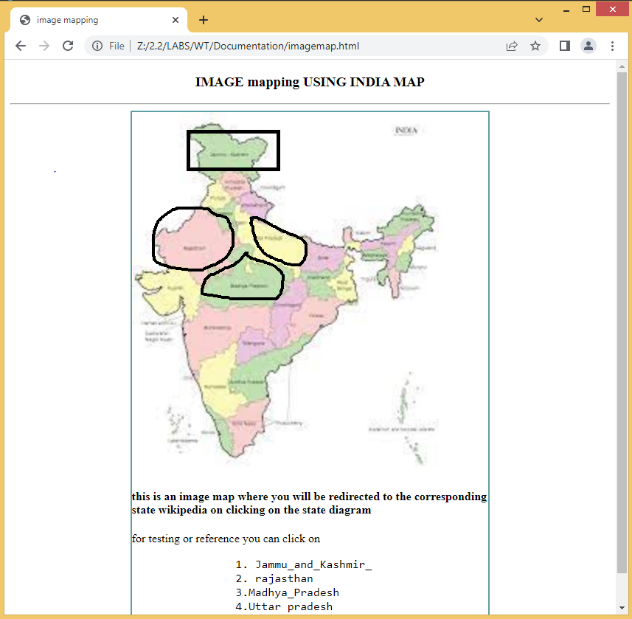

**Image map :**

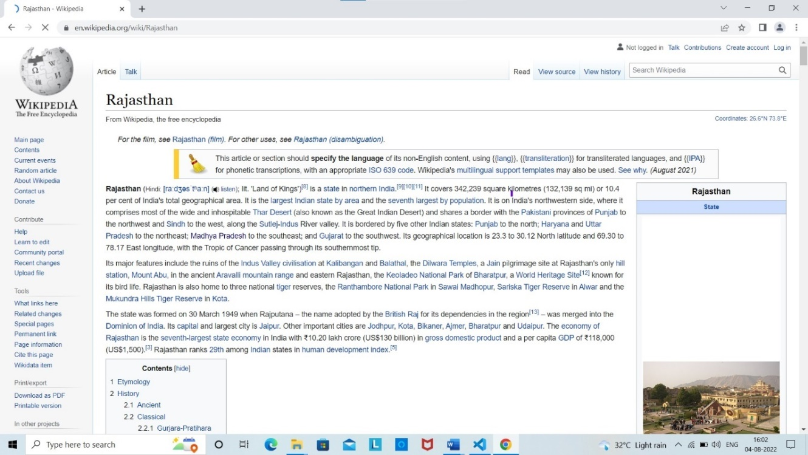

**On clicking on area Rajasthan:**

**On clicking on area Madhya Pradesh:**

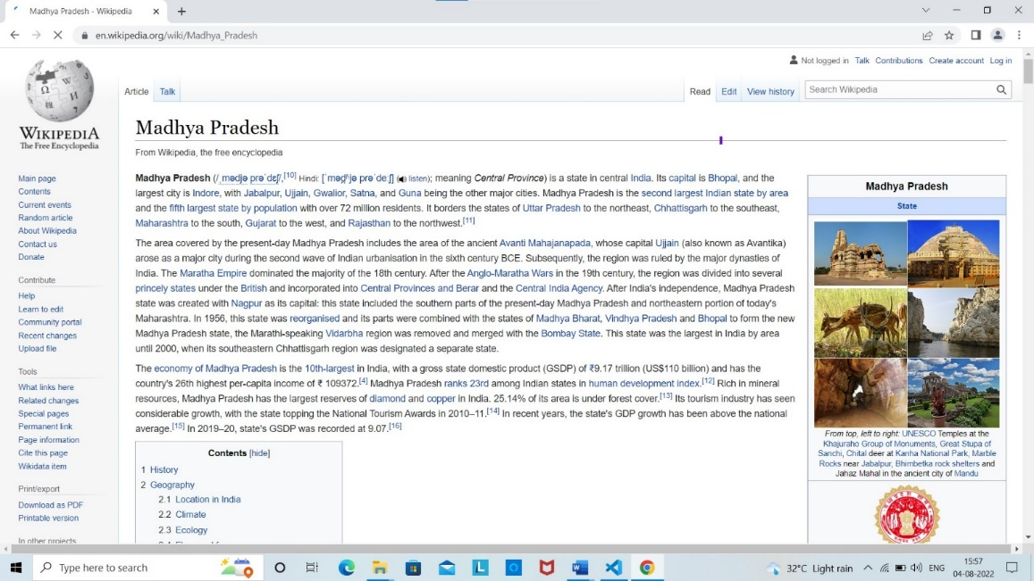

**On clicking on area Uttar Pradesh:**

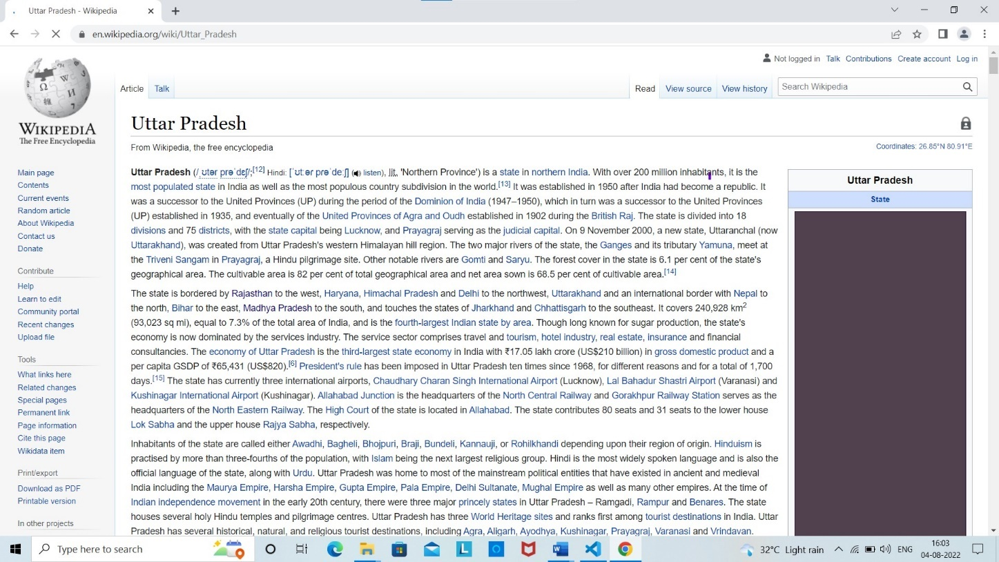

**PROGRAM-3(a) Date:07-05-2022**

**AIM:** **Write an HTML document to create registration form using all the**

**input fields.**

**SOURCE CODE:**

<!DOCTYPE html>

<html>

<head>

<title>

reg form

</title>

</head>

<body style="background-color: cornsilk;">

<div style="padding-left: 25%;padding-right: 25%; ">

<div style="background-color: rgba(0, 255, 255, 0.425); padding-right: 10%; padding-left: 10%; border:2px solid red;">

<br>

<center ><h1>STUDENT REG FORM</h1></center>

<form action="tags.html" >

<br>

<label for="">Name : </label>

<input type="text">

<br><br>

<label for="">Father's Name : </label>

<input type="text">

<br><br>

<label for="">Mother's Name : </label>

<input type="text">

<br><br>

<label for="">Email address :</label>

<input type="eamil" name="" id="" placeholder="sample@gamil.com">

<br><br>

<label for="">Reg no: </label>

<input type="text" name="" id="" pattern="[y,l][0-2][0-9]AIT[4-6][0-9][0-9]" placeholder="eg: Y20AIT507">

<br><br>

<label for="">Phone Number : </label>

<input type="tel" name="" id="" placeholder="+91XXXXXXXXXX">

<br><br>

<label for="">Gender : </label>

<input type="radio" name="gender" id="male">

<label for="">Male </label>

<input type="radio" name="gender" id="female">

<label for="">Female </label>

<input type="radio" name="gender" id="others">

<label for="">Others </label>

<br><br>

<label for="">Date of Birth :</label>

<input type="text" size="3" placeholder="dd"> - <input type="text" placeholder="mm" name="" id="" size="3"> - <input type="text" placeholder="yyyy" size="3" name="" id="">

<br><br>

<label for="blood">Blood Group:</label>

<select name="" id="">

<option value="">select</option>

<option value="">o+</option>

<option value="">AB-</option>

<option value="">B+</option>

<option value="">O-</option>

</select>

<br><br>

<label for="">Address :</label>

<textarea name="" id="" cols="23" rows="1" placeholder="add ur address as it is"></textarea>

<br><br>

<label for="">Department :</label>

<input type="radio" value="" name="dep" id="it">

<label for="it">IT</label>

<input type="radio" value="" name="dep" id="cse">

<label for="cse">CSE</label>

<input type="radio" value="" name="dep" id="ece">

<label for="ece">ECE</label>

<input type="radio" value="" name="dep" id="cs">

<label for="cs">CYBER SECURTITY</label>

<br><br>

<label for="">course :</label>

<input type="checkbox" name="" id="" >

<label for="">c++</label>

<input type="checkbox" name="" id="" >

<label for="">java</label>

<input type="checkbox" name="" id="" >

<label for="">python</label>

<input type="checkbox" name="" id="" >

<label for="">dbms</label>

<br><br>

<label for="">Please upload a photo : </label>

<input type="file" name="" id="">

<br><br>

<pre><input type="submit" name="" id=""> <input type="reset" name="" id=""></pre>

</form>

<br><br><br><br><br>

</div>

</div>

</body>

</html>

**OUTPUT:**

**Before filling:**

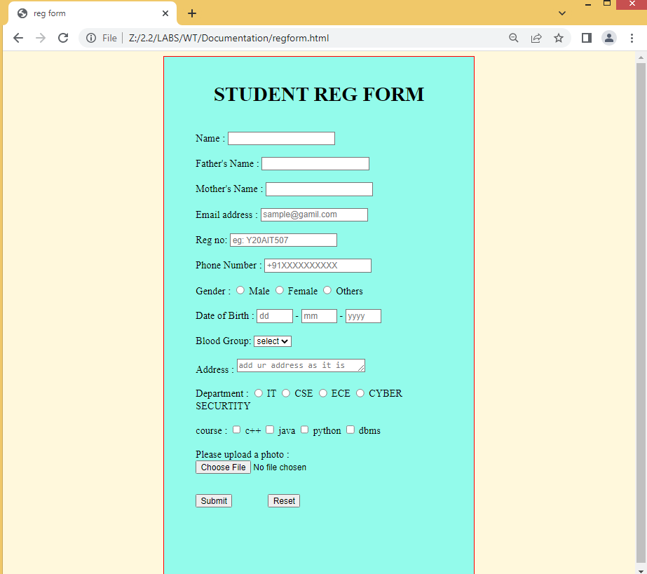

**After filling:**

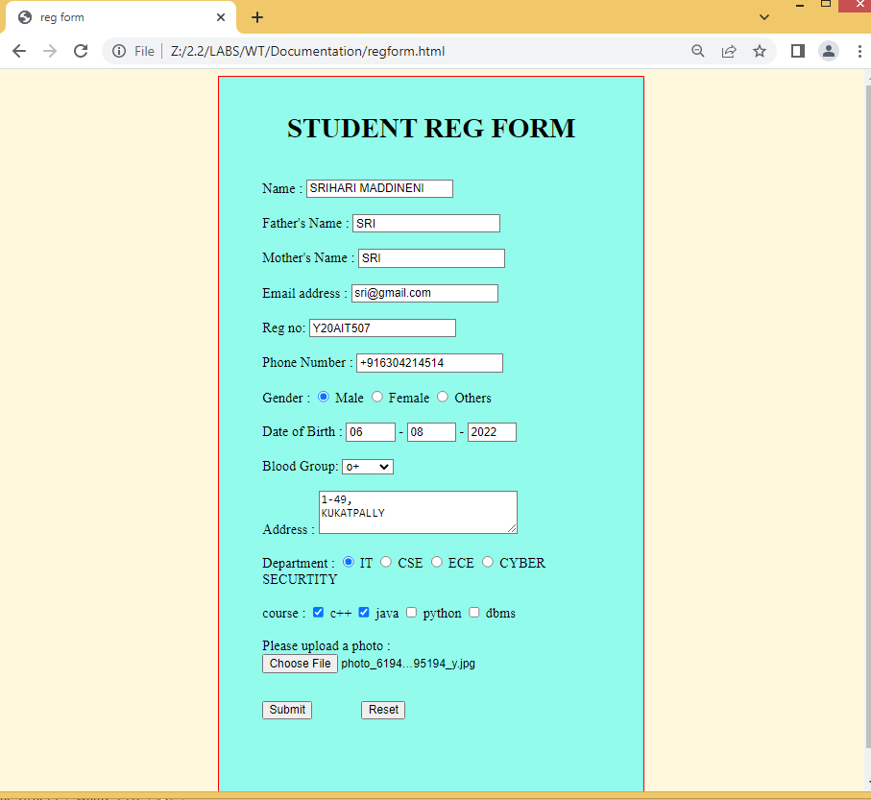

**PROGRAM-3(b) Date:07-05-2022**

**AIM:** **Write an HTML document to create a form that demnostrate the**

**label,textara,select,option,optiongroup,legend,fieldset,datalist.**

**SOURCECODE:**

<!DOCTYPE html>

<html>

<head>

<title>FORM</title>

</head>

<body>

<form action="https://www.w3schools.com/tags/tag_legend.ASP">

<fieldset style="background:yellow;border-color:red">

<legend style="background:blue;color:white">Details</legend>

<label>NAME:</label>&nbsp&nbsp&nbsp&nbsp

<input type="text" name="NAME:"><br><br><br>

<label>Father Name:</label>

<input type="text" name="Father Name:"><br><br><br>

<label>Address:</label>

<textarea name="Address:"></textarea><br><br><br>

<label>BloodGroup:</label>

<select>

<option>select</option>

<option>A+</option>

<option>B+</option>

<option>AB+</option>

<option>A-</option>

<option>B-</option>

<option>AB-</option>

</select><br>

<label> Colleges:</label>

<select>

<optgroup label="Engineering colleges">

<option>BEC</option>

<option>GEC</option>

<option>LBRCE</option>

</optgroup>

<optgroup label="Inter colleges">

<option>Inter colleges</option>

<option>Chaithanya college</option>

<option>Narayana college</option>

</optgroup>

</select><br><br>

<input type="submit" >

</fieldset>

</form>

</body>

</html>

**OUTPUT:**

**Before filling the form:**

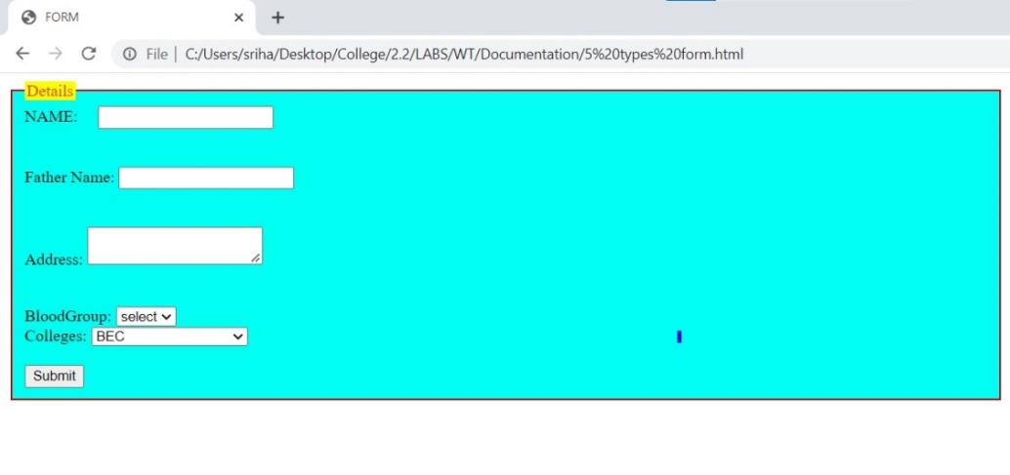

**After filling the form:**

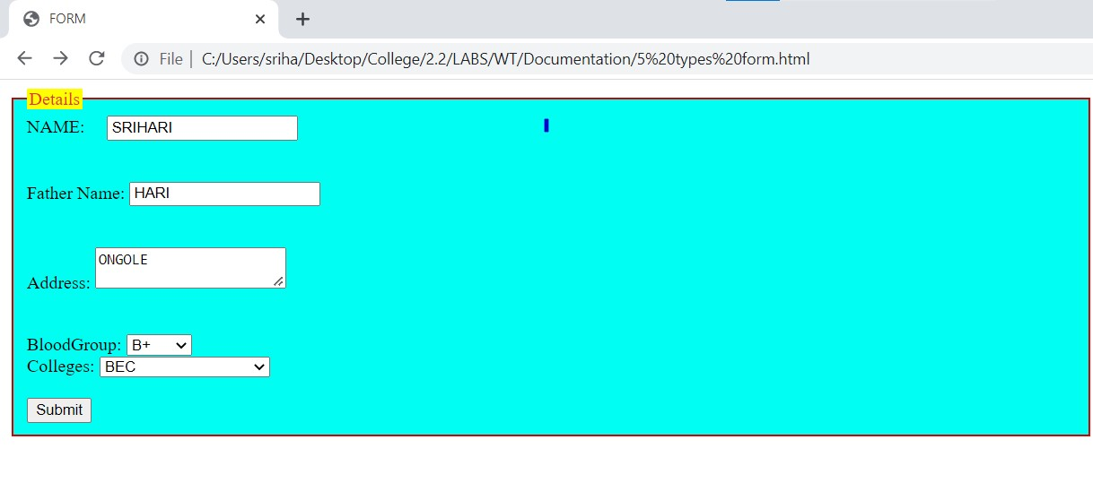

**PROGRAM-4(a) Date:14-05-2022**

**AIM:** **Demonstrate all the styles in css3**

**i) inline ii) internal iii)external**

**i)Inline style sheet**

**SOURCECODE:**

<!doctype html>

<html>

<head>

<title>inline</title>

</head>

<body style="color:rgb(255, 60, 0); background-color:rgba(18, 243, 209, 0.873); font-family:sans-serif">

<h1 style="font-size:18pt">The fontsize of this heading is 18pt</h1>

<p style="font-size:12pt">The fontsize of this paragraph is 12pt</p>

<h1 style=" color:red; background-color:yellow font-size:18pt">The fontsize of this heading is 18pt</h1>

<p style="color:#ff00a2; font-size:12pt">The fontsize of this paragraph is 18pt</p>

</body>

</html>

**(ii) Internal style sheet:**

**AIM:**

**SOURCECODE:’**

<!DOCTYPE HTML>

<html>

<head>

<title>Internal style sheet</title>

<style>

*{

margin:0;

}

body{

color:red;

background-color:rgb(31, 178, 218);

font-family:sans serif;

h1{font-size:18pt;}

}

p{

font-size:12pt;

color:rgb(255, 234, 0);

}

</style>

</head>

<body>

<h1>H1 with fontsize 18pt</h1><br>

<p>A paragraph with fontsize 12pt</p><br><br>

<h1 style="color:green;background-color:yellow;font-size:14pt";>

A heading h1 with fontsize 14pt

</h1><br>

<p style="color:rgb(234, 255, 0);font-family:Ariel;background-color:rgba(34, 139, 34, 0.666);fontsize:14pt">The font size of this paragraph is 12pt</p>

</body>

</html>

**(iii) External style sheet;**

**AIM:**

**SOURCECODE:**

<!DOCTYPE HTML>

<head>

<TITLE>CSS Example </TITLE>

<LINK rel="stylesheet" type="text/css" href="example.css"/>

</head>

<body>

<h1>A table representing companys and ceo's</h1><br>

<p>It also shows whether ceo is from India or not!</p>

<table>

<tr>

<th>Company name</th>

<th>CEO</th>

</tr>

<tr>

<td class="code">Google</td>

<td>Sundar Pichai,Indian</td>

</tr>

<tr>

<td class="code">Amazon</td>

<td>Zeff Bezos,Non Indian</td>

</tr>

<tr>

<td class="code">Tesla</td>

<td>Elon musk,Non Indian</td>

</tr>

<tr>

<td class="code">Microsoft</td>

<td>Satya Nadella</td>

</tr>

</table>

</body>

</html>

**Example.css:**

/*style sheet for sample.html*/

*{margin:0;}

body

{

color:red;

background-color:rgb(144, 238, 238);

font-family:sans-serif;

}

h1{font-family:18pt;}

p{font-size:12pt;}

table{

background-color:yellow;

border-color:green;

border-width:2px;

border-style:solid;

}

th{

background-color:rgb(34, 255, 0);

font-weight:bold;

padding:3px;

}

td{padding:3px;}

td.code

{

font-weight:bold;

font-family:sans-serif;

}

**Linking:**

<!DOCTYPE HTML>

<head>

<TITLE>CSS Example using import </TITLE>

<style type="text/css"> @import url("example.css");

p{color:red}

</style>

</head>

<body>

<h1>A table representing companys and ceo's</h1><br>

<p>It also shows whether ceo is from India or not!</p>

<table>

<tr>

<th>Company name</th>

<th>CEO</th>

</tr>

<tr>

<td class="code">Google</td>

<td>Sundar Pichai,Indian</td>

</tr>

<tr>

<td class="code">Amazon</td>

<td>Zeff Bezos,Non Indian</td>

</tr>

<tr>

<td class="code">Tesla</td>

<td>Elon musk,Non Indian</td>

</tr>

<tr>

<td class="code">Microsoft</td>

<td>Satya Nadella</td>

</tr>

</table>

</body>

</html>

**Example.css:**

/*style sheet for sample.html*/

*{margin:0;}

body

{

color:red;

background-color:rgb(144, 238, 238);

font-family:sans-serif;

}

h1{font-family:18pt;}

p{font-size:12pt;}

table{

background-color:yellow;

border-color:green;

border-width:2px;

border-style:solid;

}

th{

background-color:rgb(34, 255, 0);

font-weight:bold;

padding:3px;

}

td{padding:3px;}

td.code

{

font-weight:bold;

font-family:sans-serif;

}

**OUTPUT:**

**Inline css:**

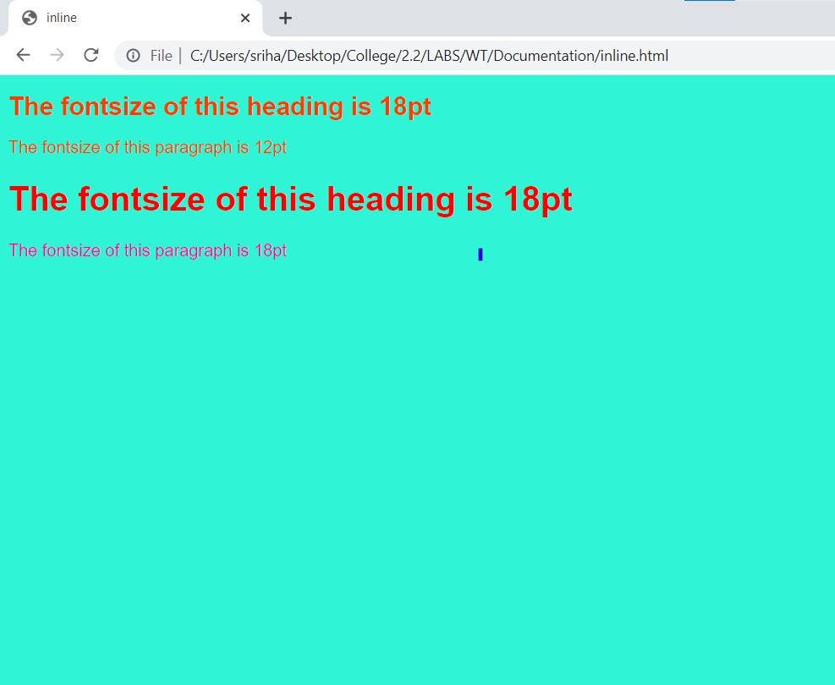

**Internal css:**

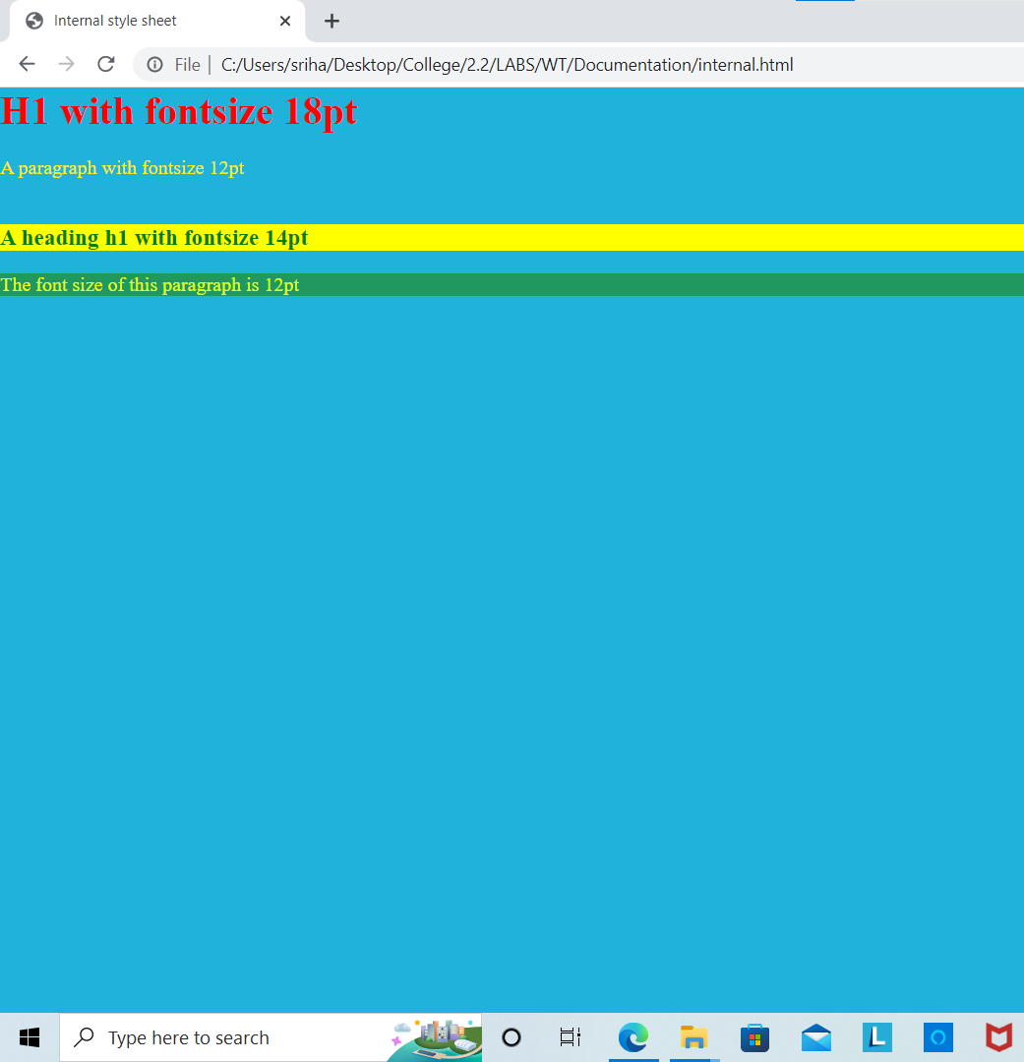

**External css:**

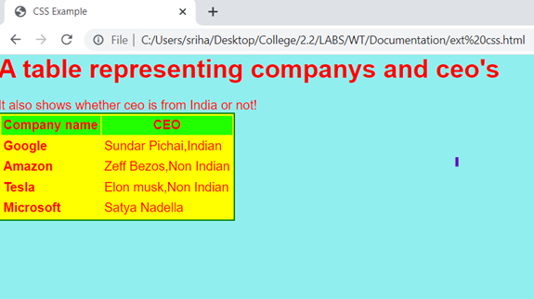

**Css linkage using @import:**

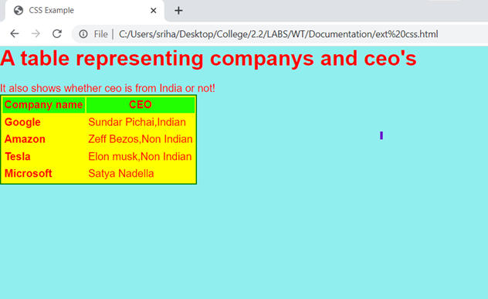

**Program-4(b) Date:14-05-2022**

**Aim: Demonstrate all the styles in css3 query selector**

**Source code:**

<!DOCTYPE HTML>

<html>

<head>

<title>query selector</title>

<script type="text/javascript">

function qsel()

{ document.querySelector("p").style.background="green"; }

function qselall()

{

list=document.querySelectorAll("p");

for(var i=0;i<list.length;i++)

{

list[i].style.background="red";

}

}

</script>

</head>

<body>

<p>My paragraph1</p>

<p>My paragraph2</p>

<p>My paragraph3</p>

<p>My paragraph4</p>

<p>My paragraph5</p>

<button onclick="qsel()">selector</button>

<button onclick="qselall()">selector All</button>

</body>

</html>

**OUTPUT:**

**Before buttons clicked:**

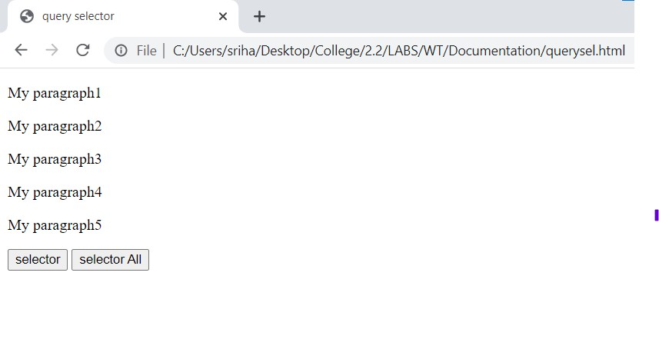

**Query selector clickage:**

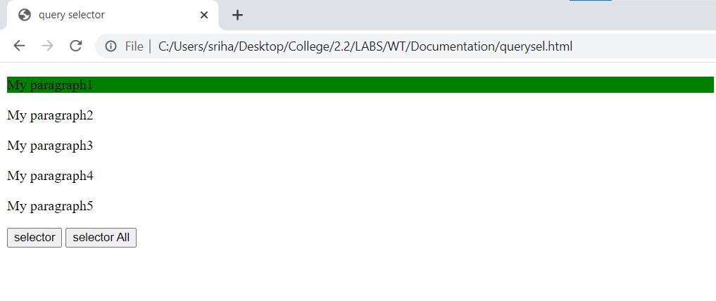

**Query selector all clickage:**

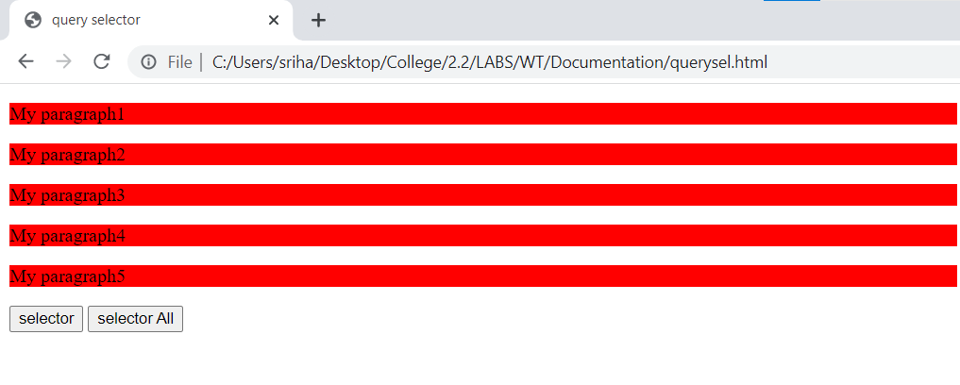

**Program-5 (a) Date:25-06-2022**

**Aim: Write a javascript program to demonstrate the Mouse events**

**Source code:**

<!DOCTYPE html>

<html lang="en">

<head>

<title>mouse events</title>

<script type="text/javascript">

function mo(){

document.getElementById("m1").style.background="red";

}

function me(){

document.getElementById("m2").style.color="blue";

}

function ml(i){

i.height=200;

i.width=200;

}

function db(){

document.getElementById("m4").style.border="solid 2px red";

}

function od(){

document.getElementById("m5").style.fontFamily="monospace"

}

function oc(){

document.getElementById("m6").style.background="blue";

}

function mm(){

alert("mouse moved over image")

}

function mout(){

alert("mouse out happened")

}

</script>

</head>

<body>

<p id="m1" onmouseover="mo()">ON MOUSE OVER</p>

<p id="m2" onmouseenter="me()">ON MOUSE ENTER</p>

<img id="m3" onmouseleave="ml(this)" src="image.jpg" alt="hello">

<p id="m4" ondblclick="db()">ON DOUBLE CLICK</p>

<p id="m5" ondrag="od()">ON DRAG</p>

<p id="m6" onclick="oc()">ON CLICK</p>

<img id="m7" onmousemove="mm(this)" src="image.jpg" alt="hello"><br><br>

<img id="m8" onmouseout="mout()" src="image.jpg" alt="hello">

</body>

</html>

**OUTPUT:**

**Before mouse evennts handled:**

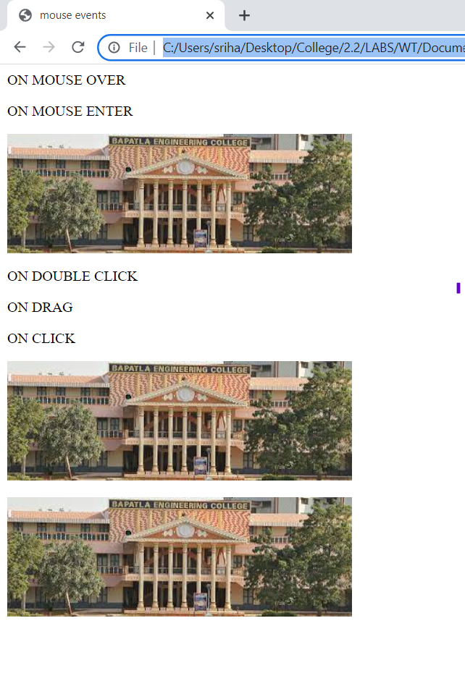

**After mouse events handled:**

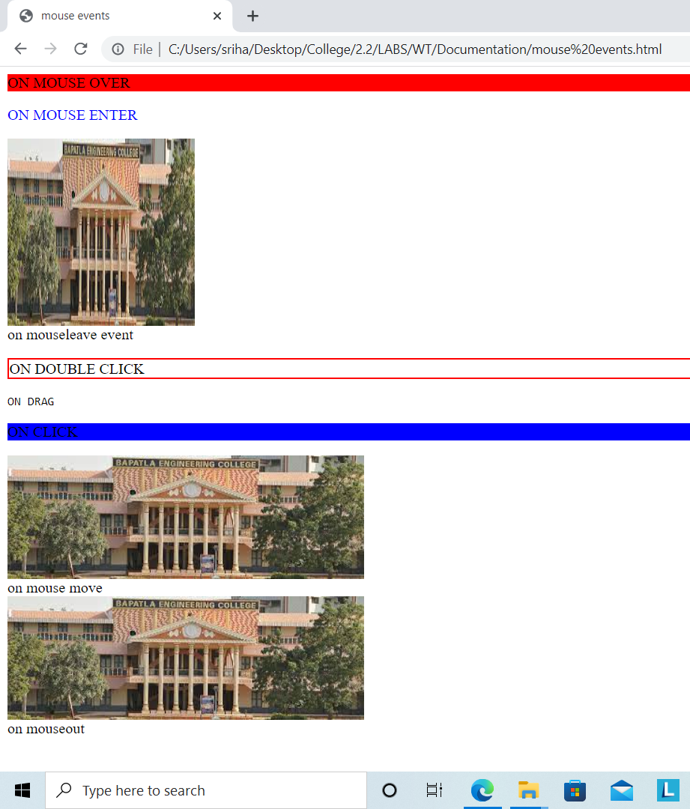

**On mouse out from image 2:**

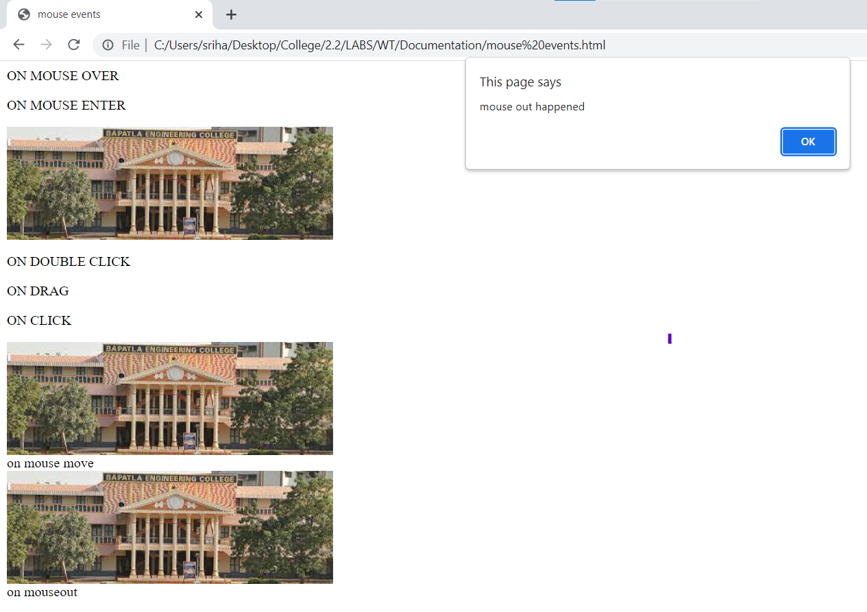

**On mouse moved from image 3:**

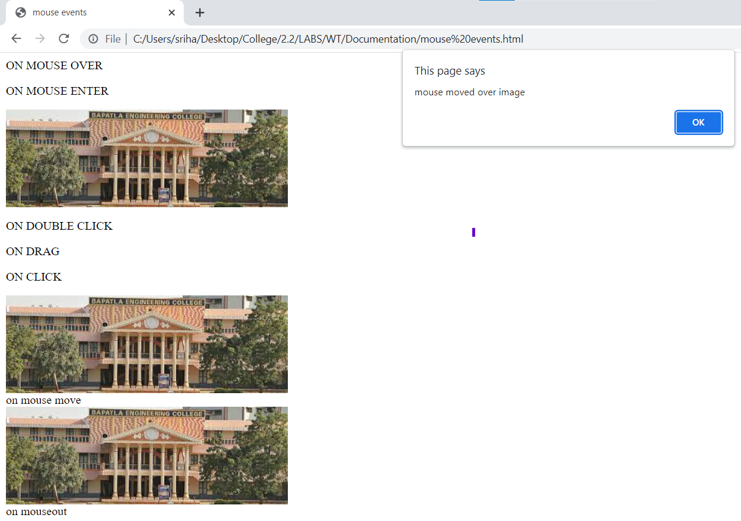

**Program-5(b) Date:25-06-2022**

**Aim: Write a javascript program to demonstrate the Form events**

**Source code:**

<!DOCTYPE HTML>

<html>

<head>

<title>Form events</title>

<script>

function osu(){ confirm("Are you sure you want to submit"); }

function oi(){ alert("Invalid submission"); }

function ofo(){ document.getElementById("f").style.background="cyan"; }

function or(){

document.getElementById("p").innerHTML="Form reset done!"; }

function ob(){

document.getElementById("f").style.background="red"; }

function os(){

document.getElementById("p").innerHTML="You selected the content of input field"; }

function oc(){

document.getElementById("p").innerHTML="You changed the content of input field"; }

</script>

</head>

<body>

<form action="" onsubmit="osu()" onreset="or()" required>

name : <input type="email" id="f" onfocus="ofo()" onblur="ob()" onselect="os()" onchange="oc()" oninvalid="oi()" >

<input type="submit">&nbsp; <input type="reset" >

</form>

<h3 id="p" ></h3>

</body>

</html>

**OUTPUT:**

**Before form events handled:**

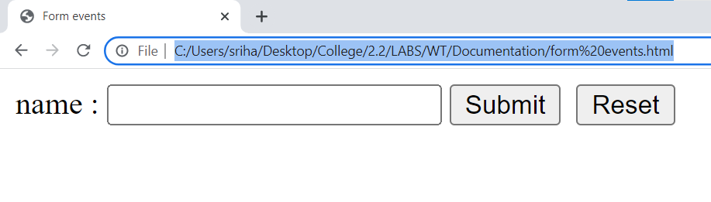

**On focus:**

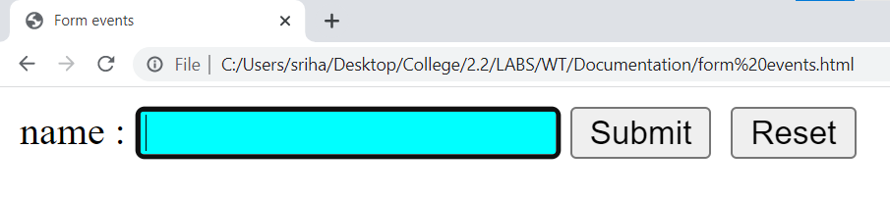

**On blur:**

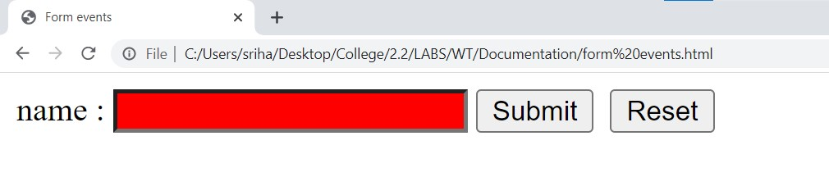

**On select:**

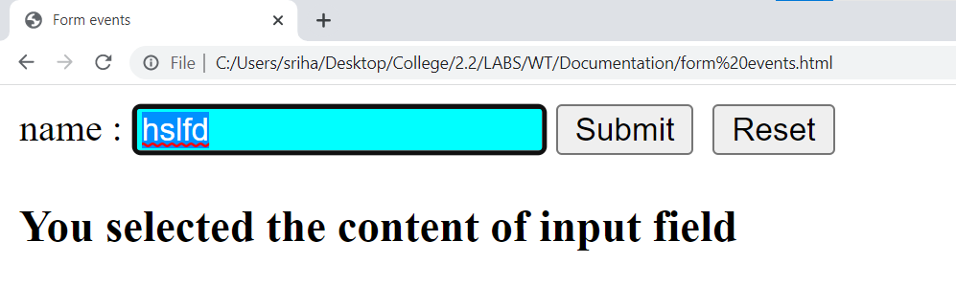

**On invalid submission:**

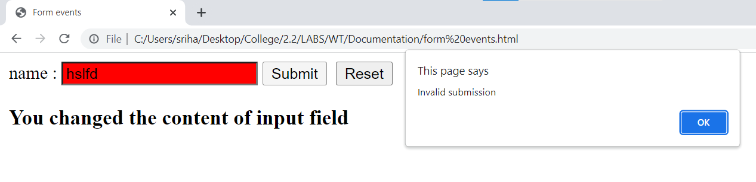

**On reset:**

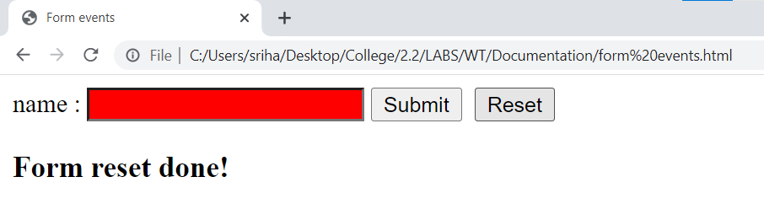

**Program-5(c) Date:25-06-2022**

**Aim**: **Write a javascript program to demonstrate the pop-ups**

**Source code:**

<!DOCTYPE html>

<html>

<head>

<title>Demonstrate Popup boxes</title>

<script type="text/javascript">

function al(){

alert("This is alert msge as u clicked on alert box");

}

function cnf(){

confirm("Are you sure u want to continue?");

}

function pro(){

var n=prompt("plz enter ur name");

document.getElementById("pmsg").innerHTML="your name is :"+n;

}

</script>

</head>

<body>

<h1>Dempnstrate Popup boxes</h1>

<button onClick="al()">Alertbox</button><br><br>

<button onClick="cnf()">confirmbox</button><br><br>

<button onClick="pro()">promptbox</button>

<p id="pmsg"></p>

</body>

</html>

**OUTPUT:**

**Before popup boxes activated:**

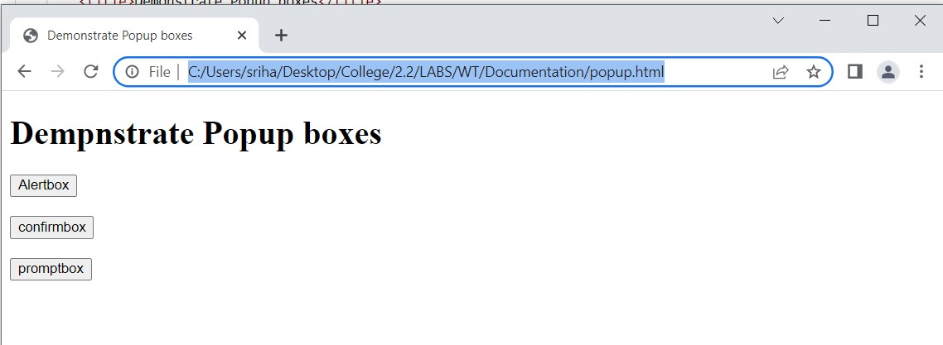

**Alert box:**

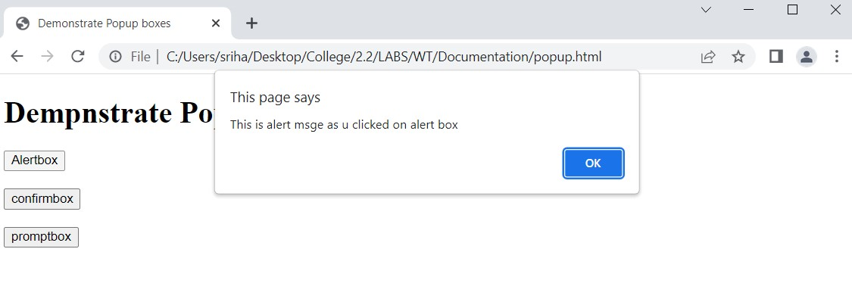

**Confirm box:**

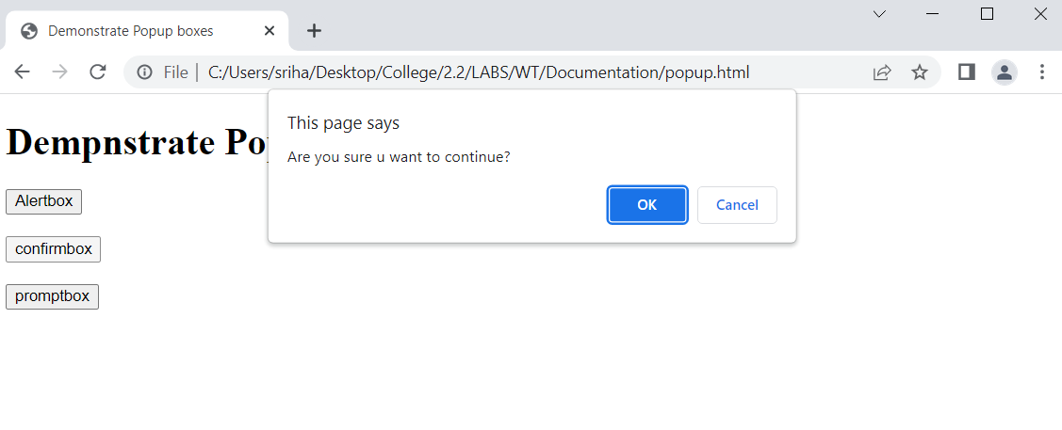

**Prompt box:**

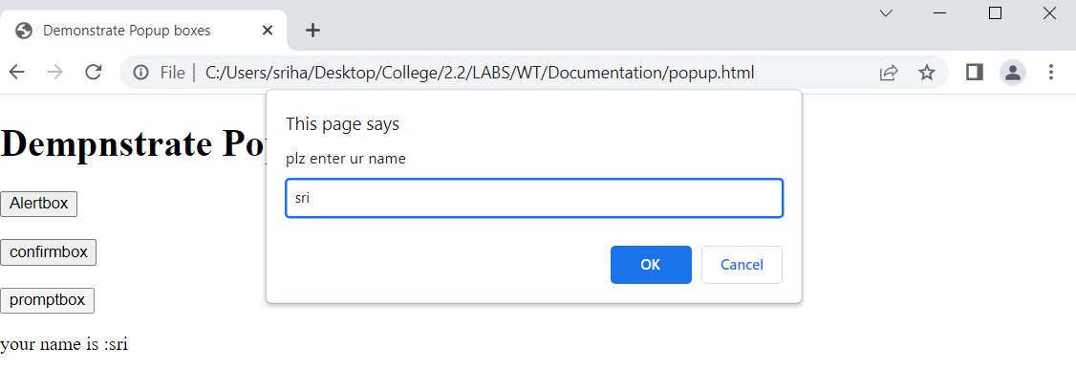

**Program-6(a) Date:01-07-2022**

**Aim: Write a javascript program to demonstrate the String objects.**

**Source code**:

<!Doctype html>

<html>

<head>

<title>js demo 3</title>

</head>

<body>

<script>

var s="hello world";

var t="hi man";

document.write("<h1>methods in string object</h1>")

document.write("replace hel with hi :"+s.replace('hel','hi')+"<br>");

document.write("search: "+"".search('p')+"<br>");

document.write(s.search('hel')+"<br>");

document.write(s.search('wor')+"<br>");

document.write("slice: "+s.slice(2,5)+"<br>");

document.write("lowercase :"+s.toLowerCase()+"<br>");

document.write("uppercase:"+s.toUpperCase()+"<br>");

document.write("valueof s :"+s.valueOf()+"<br>");

document.write("index of l is: "+s.indexOf('l')+"<br>");

document.write("concatanation :"+s.concat(t)+"<br>");

document.write("charcode at: "+s.charCodeAt(5)+"<br>");

document.write("char at:"+s.charAt(6)+"<br>");

document.write("last indexof e is: "+s.lastIndexOf('e')+"<br>");

document.write("match of o is at:"+s.match('o')+"<br>");

document.write("match of p :"+s.match('p')+"<br>");

document.write("<h1>properties in string object</h1>")

document.write("big size: "+s.big()+"<br>");

document.write("small size:"+s.small()+"<br>");

document.write("bold letters :"+s.bold()+"<br>");

document.write("font color : "+s.fontcolor("red")+"<br>");

document.write("font size : "+s.fontsize("50px")+"<br>");

document.write(s.match('p')+"<br><br>");

document.write("<br>Link:"+s.link());

document.write("<br>strike-out text:"+s.strike());

document.write("<br>subscript:"+t.sub());

document.write("<br>supscript:"+t.sup());

document.write("<br>Italic text:"+s.italics());

document.write("<br>strike-out text:"+s.strike());

document.write("<br>Text Blink:"+s.blink());

</script>

</body>

</html>

**OUTPUT:**

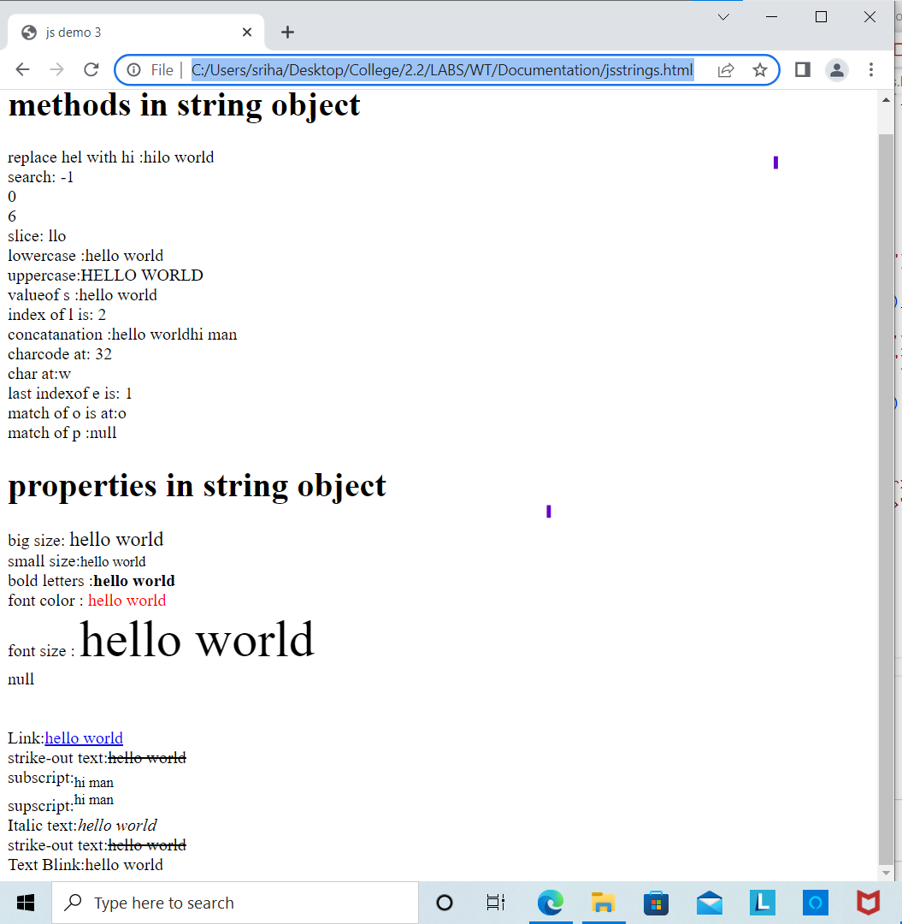

**Program-6(b) Date:02-07-2022**

**Aim: Write a javascript program to demonstrate the Math object.**

**Source code:**

<!DOCTYPE html>

<html>

<head>

<title> Math Object</title>

</head>

<body >

<script type="text/javascript">

document.write("<h2>Math object properties</h2>");

document.write("Euler's number E:"+Math.E);

document.write("<br>natural logarithmic of 2:"+Math.LN2);

document.write("<br>natural logarithmic of 10:"+Math.LN10);

document.write("<br>base-2 logarithmic of E:"+Math.LOG2E);

document.write("<br> base-10 logarithmic of E:"+Math.LOG10E);

document.write("<br>Number value of PI:"+Math.PI);

document.write("<br>Square root of 1/2:"+Math.SQRT1_2);

document.write("<br> Square root of 2:"+Math.SQRT2);

document.write("<h2>Math object methods</h2>");

document.write("absolute value of pi:"+Math.abs(Math.PI));

document.write("<br>natural logarithm of 20:"+Math.log(20));

document.write("<br>max value among (5,6,7,8,9):"+Math.max(5,6,7,8,9));

document.write("<br>min value among (5,6,7,8,9):"+Math.min(5,6,7,8,9));

document.write("<br>the value of S to the power of 2:"+Math.pow (5,2));

document.write("<br>random number between 0 and 1:"+Math.random());

document.write("<br>square root of 16:"+Math.sqrt(16));

</script>

</body>

</html>

**OUTPUT:**

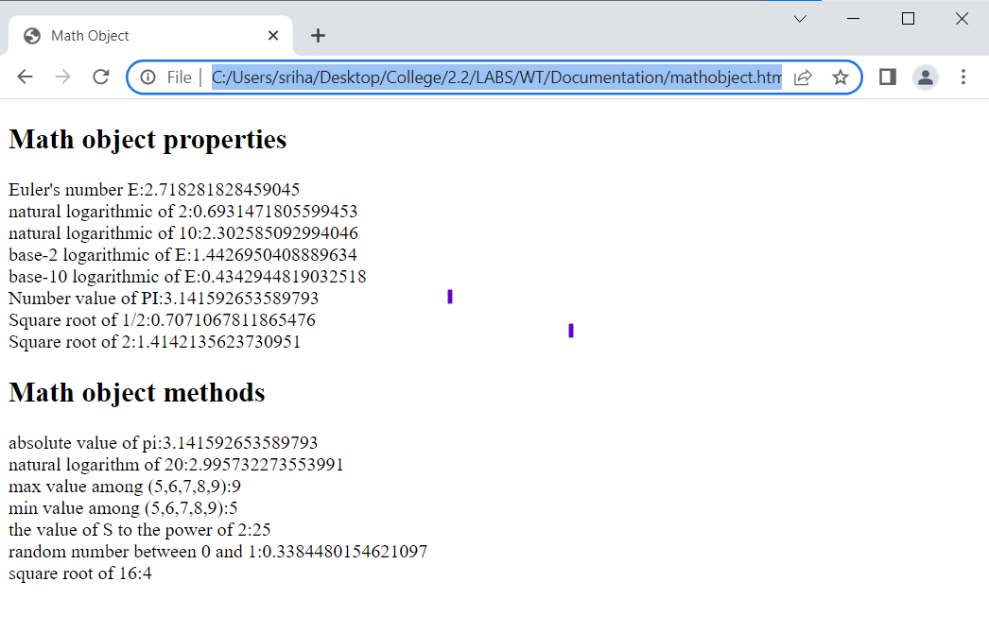

**Program-6(c) Date:02-07-2022**

**Aim: Write a javascript program to demonstrate the Date object.**

**Source code:**

<!DOCTYPE htm|>

<html>

<head>

<title> Date objects</title>

</head>

<body>

<script type="text/javascript">

var d1= new Date();

var d2=new Date(2000000);

var d3=new Date("july 08,2022");

var d4=new Date(2022,00,01);

var d5=new Date(2022,00,01,10,45,30);

document.write("<h2>Date object creation</h2>");

document.write("Empty Date object creation:"+d1);

document.write("<br>Date object with milliseconds:"+d2);

document.write("<br>Date object with string:"+d3);

document.write("<br>Date object with specified date:"+d4);

document.write(" <br> Date object with specified date & time:"+d5);

document.write("<h2>Date object methods</h2>");

document.write("Current Date:"+Date(d1.valueOf()));

document.write("<br>Day:"+d1.getDay());

document.write("<br>Date:"+d1.getDate());

document.write("<br>Month."+d1.getMonth());

document.write("<br>Year:"+d1.getFullYear());

document.write("<br>Hourse:"+d1.getHours());

document.write("<br>Minutes:"+d1.getMinutes());

document.write("<br>Seconds:"+d1.getSeconds());

document.write("<br>Milliseconds:"+d1.getMilliseconds());

document.write("<br>Time:"+Date(d1.getTime()));

document.write("<br>difference between UTC time and local time, in minutes:"+d1.getTimezoneOffset());

document.write("<br>Setting the Date:"+d1.setDate(10));

document.write("<br>getting the Date:"+d1.getDate());

</script>

</body>

</html>

**OUTPUT:**

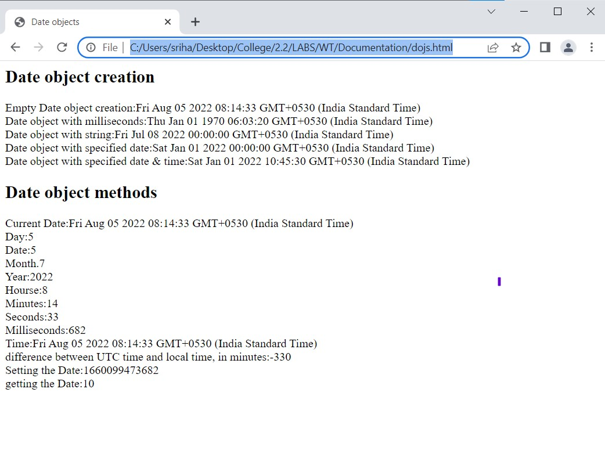

**Program-7(a) Date:09-07-2022**

**Aim: Write a javascript program to demonstrate Window objects**

**Source code:**

<!DOCTYPE html>

<html>

<head>

<title>Window object</title>

</head>

<body>

<h2>Frames</h2>

<iframe src="popup.html" width="200" height="200"></iframe>

<iframe src="mouse events.html" width="200" height="200"></iframe>

<iframe src="" width="200" height="200"></iframe>

<h2>window object methods</h2>

<button id="but1" onclick="win=window.open('tags.html')">OpenWindow</button>&nbsp;&nbsp;&nbsp;&nbsp;

<button id="but1" onclick="win.close()">close Window</button>&nbsp;&nbsp;&nbsp;&nbsp;

<button id="but1" onclick="window.alert('Alert Message')">Alert</button>&nbsp;&nbsp;&nbsp;&nbsp;

<button id="but1" onclick="window.prompt('prompt Message')">Prompt</button>&nbsp;&nbsp;&nbsp;&nbsp;

<button id="but1" onclick="window.confirm('confirm message')">confirm</button>&nbsp;&nbsp;&nbsp;&nbsp;

<button id="but1" onclick="win.moveBy('100,100')">Move Window</button>&nbsp;&nbsp;&nbsp;&nbsp;

<h2>window object properties</h2>

<script type="text/javascript">

document.write("Number of Frames Used are:"+window.length);

window.frames[2].location="tags.html";

document.write("<br><u>Innerheight:</u> height of the windows content area(viewport)including scrollbars:"+window.innerHeight);

document.write("<br><u>Innerwidth:</u> width of the windows content area(viewport)including scrollbars:"+window.innerWidth);

document.write("<br><u>outerheight:</u> height of the browser window,including toolbars/scrollbars:"+window.outerHeight);

document.write("<br><u>outerwidth:</u> width of the browser window,including toolbars/scrollbars:"+window.outerWidtht);

</script>

</body>

</html>

**Output:**

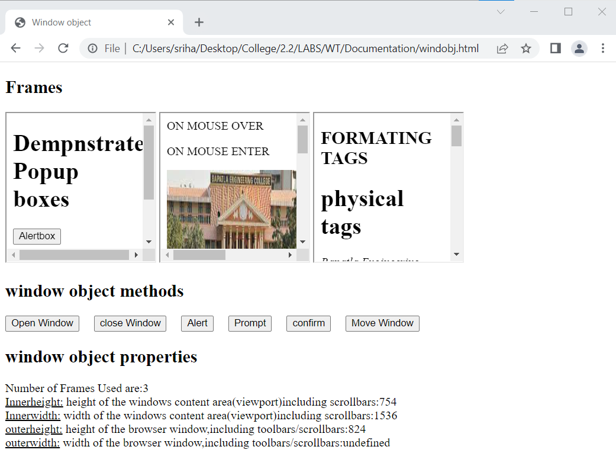

**On opening a window using the button available:**

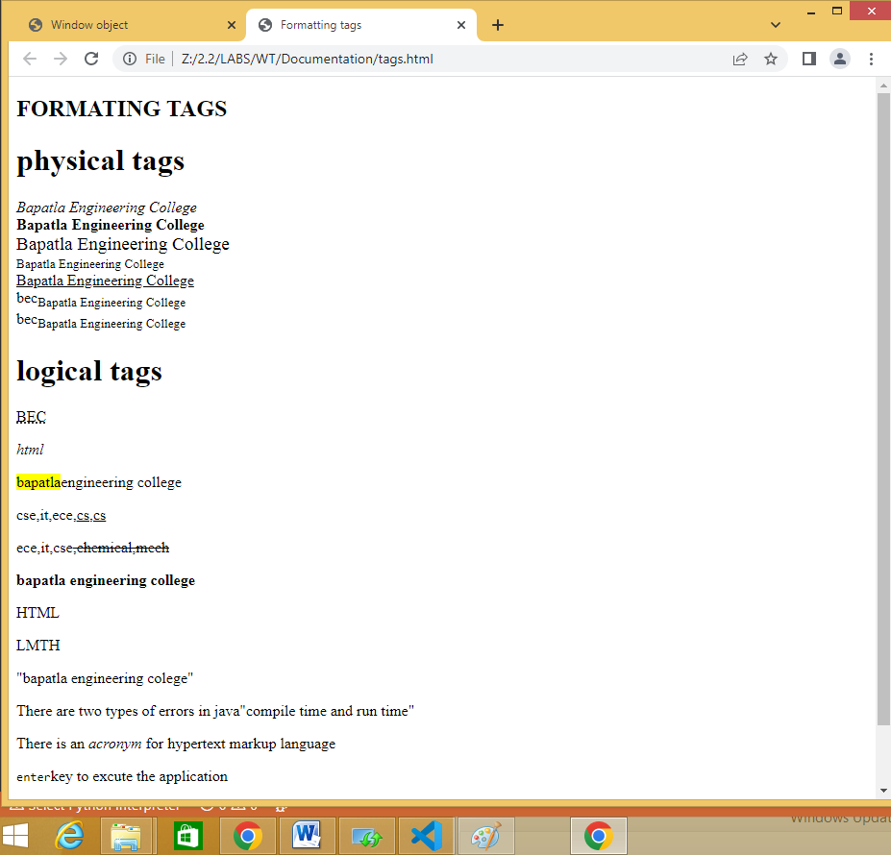

**Program-7(b) Date:09-07-2022**

**Aim**: **Write a javascript program to demonstrate document objects**

**Source code:**

<!DOCTYPE HTML>

<html>

<head> <title>Document Object</title> </head>

<body>

<h2>Images</h2>

Image 1:<img id ="imgl" src="bec logo.png" width="100" height="100">

Image 2:<img id ="img2" src="nature1.jpg" width="100" height="100">

<h2>Links</h2>

<a id="link1" href="mouse.html">Pagel</a><a id ="link2" href="formev.html">Page2</a>

<h2>Docuemnt object methods</h2>

<button onclick="open_doc()">Open Docuemnt</button>

<script type="text/javascript">

document.write("<h2>Document object collection</h2>");

document.write("Number of images:"+document.images.length);

document.write("<br>Number of links:"+document.links.length);

document.write("<h2>Document object properties</h2>");

document.write("Title of docuemnt:"+document.title);

document.write("<br>URL of docuemnt:"+document.URL);

document.write("<br> state of docuemnt:"+document.readyState);

document.write("<br>lastmodified of docuemnt:"+document.lastModified);

function open_doc(){

var mywindow = window.open();

mywindow.document.open();

mywindow.document.write("<h1>Welcome to document</h1>");

mywindow.document.close();

}

</script>

</body>

</html>

**OUTPUT:** +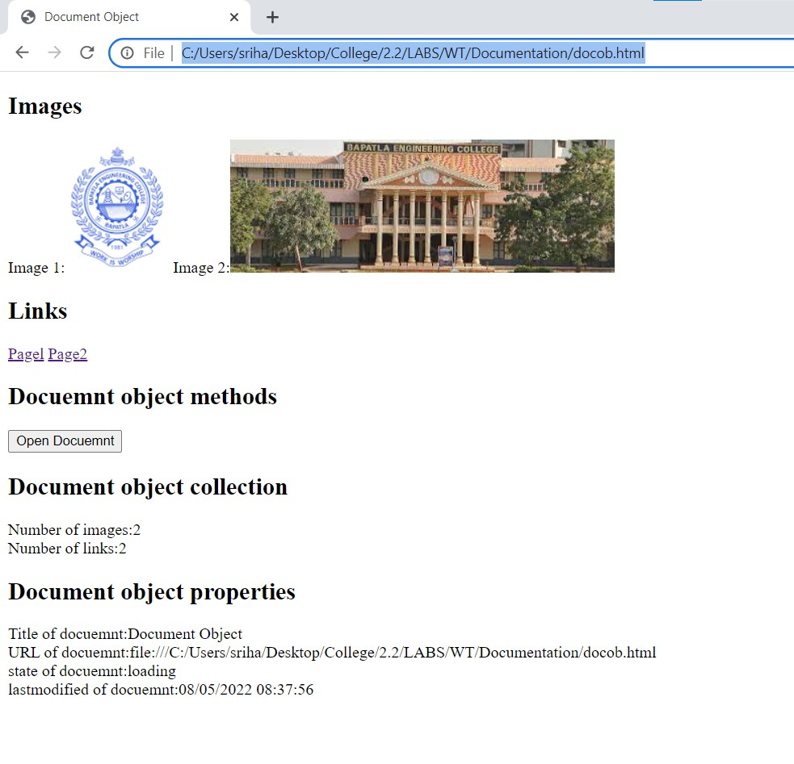

**On clicking open document:**

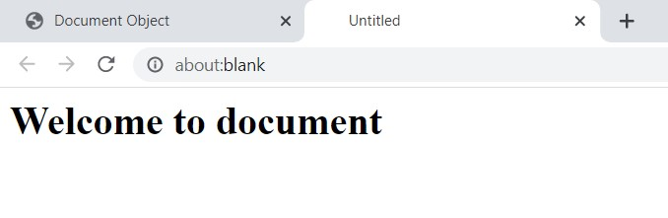

**On clicking a page1 link:**

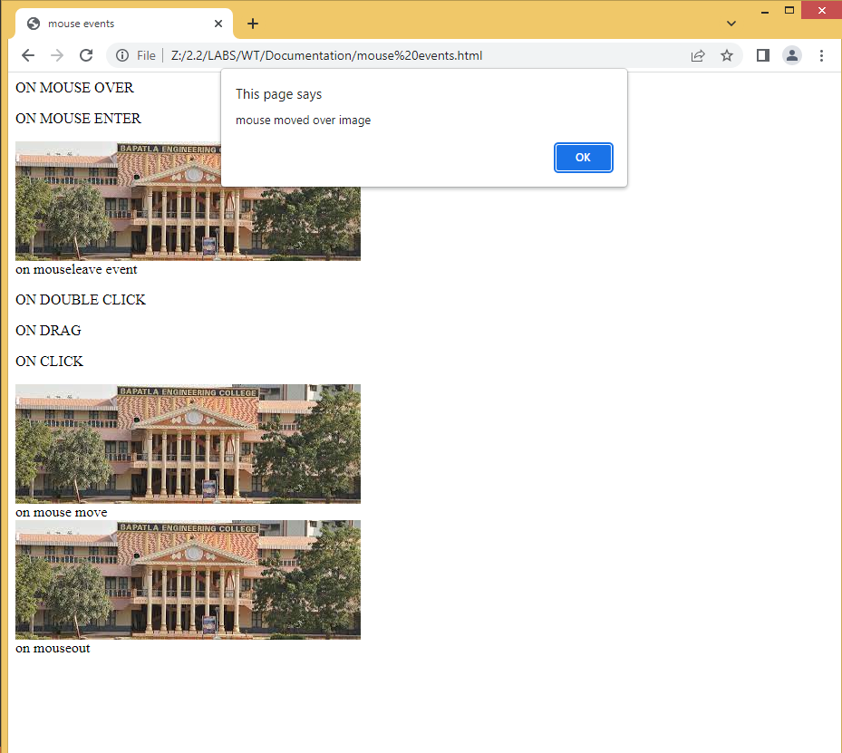

**Program-8(i) Date:16-07-2022**

**Aim: Write a javascript program to a.create ,b.delete, c.duplicate,and d.insert a node before element using docnode interface.**

**Source code:**

<!DOCTYPE html>

<html>

<head>

<title>node interface</title>

<script type="text/javascript">

function create_node(){

var link=document.createElement("a");

link.setAttribute("id","li");

link.setAttribute("href","image.jpg");

link.setAttribute("width","100");

link.setAttribute("height","100");

text=document.createTextNode("my link");

link.appendChild(text);

document.body.appendChild(link);

}

function delete_node(){

child=document.getElementById("li");

document.body.removeChild(child);

}

function clone_node(){

link=document.getElementById("li");

c=link.cloneNode(true);

document.body.appendChild(c);

}

function insert_node(){

link=document.getElementById("ll");

para=document.createElement("p");

para.setAttribute("id","p1");

text=document.createTextNode("my paragraph before link");

para.appendChild(text);

document.body.insertBefore(para,link);

}

</script>

</head>

<body>

<div id="d">

<h2>Node interface methods</h2>

<button onclick="create_node()">create link</button>

<button onclick="delete_node()">remove link</button>

<button onclick="clone_node()">clone link</button>

<button onclick="insert_node()">insert paragraph before link</button>

</div>

</body>

</html>

**OUTPUT:**

**Before clicking on nodes:**

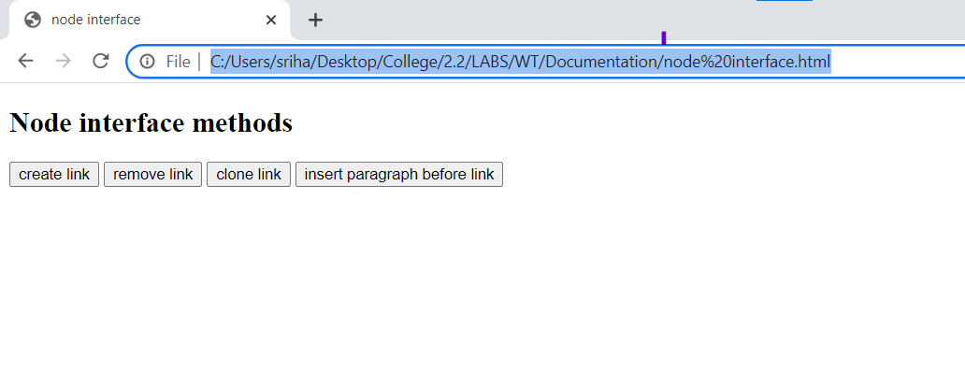

**After creating a node:**

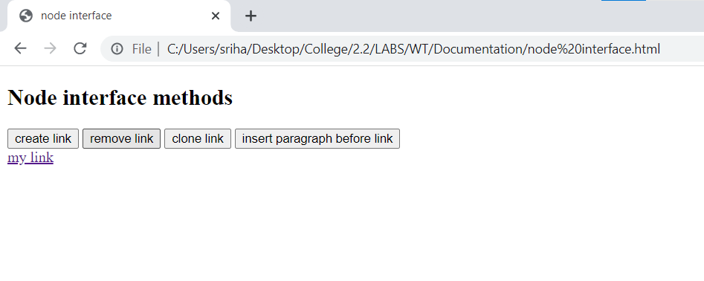

**On clicking on the created link:**

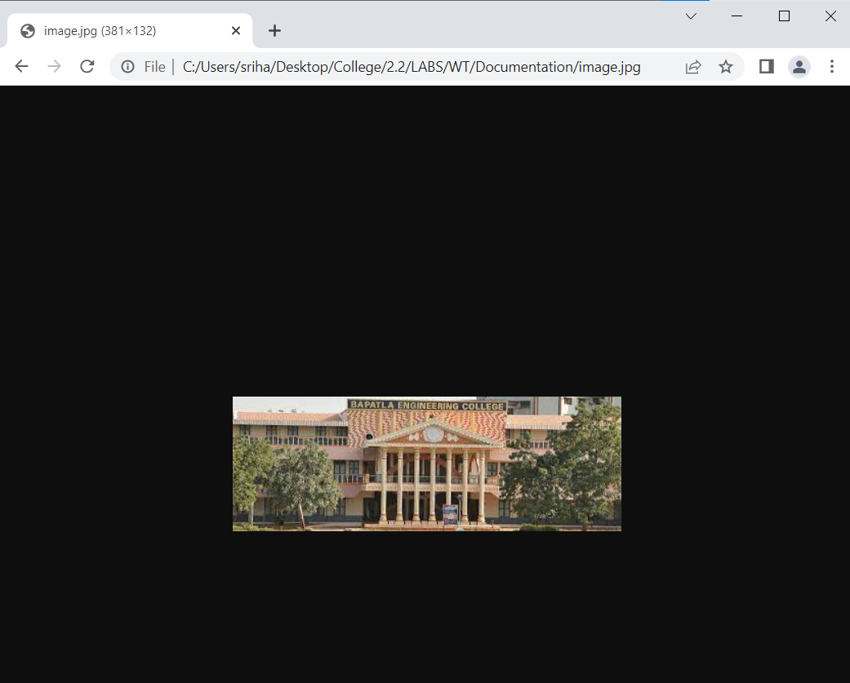

**After cloning and inserting paragraphs:**

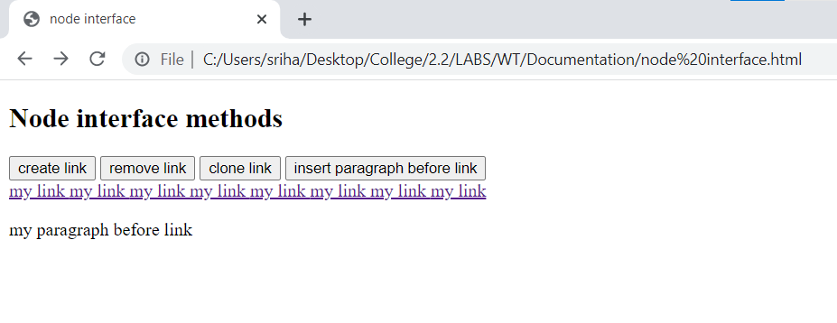

**Program-8(ii) Date:16-07-2022**

**Aim: Develop simple web application calculator**

**Source code:**

<!DOCTYPE HTML>

<html>

<head><title>calculator</title>

<script type="text/javascript">

function dis(val){

document.getElementById("result").value+=val

}

function solve(){

var x = document.getElementById("result").value

var y = eval(x)

document.getElementById("result").value = y

}

function clr(){

document.getElementById("result").value = ""

}

</script>

</head>

<body>

<table >

<tr>

<td colspan="3"><input type="text" id="result" style="text-align:right; width: 100px;" ></td>

<td><input type="button" value="AC" onclick="clr()" /> </td>

</tr>

<tr>

<td><input type="button" value="1" onclick="dis('1')"/> </td>

<td><input type="button" value="2" onclick="dis('2')"/></button> </td>

<td><input type="button" value="3" onclick="dis('3')"/> </td>

<td><input type="button" value="/" onclick="dis('/')"/> </td>

</tr>

<tr>

<td><input type="button" value="4" onclick="dis('4')"/> </td>

<td><input type="button" value="5" onclick="dis('5')"/> </td>

<td><input type="button" value="6" onclick="dis('6')"/> </td>

<td><input type="button" value="-" onclick="dis('-')"/> </td>

</tr>

<tr>

<td><input type="button" value="7" onclick="dis('7')"/> </td>

<td><input type="button" value="8" onclick="dis('8')"/> </td>

<td><input type="button" value="9" onclick="dis('9')"/> </td>

<td><input type="button" value="+" onclick="dis('+')"/> </td>

</tr>

<tr>

<td><input type="button" value="." onclick="dis('.')"/> </td>

<td><input type="button" value="0" onclick="dis('0')"/> </td>

<td><input type="button" value="=" onclick="solve()"/> </td>

<td><input type="button" value="*" onclick="dis('*')"/> </td>

</tr>

</table>

</body>

</html>

**OUTPUT:**

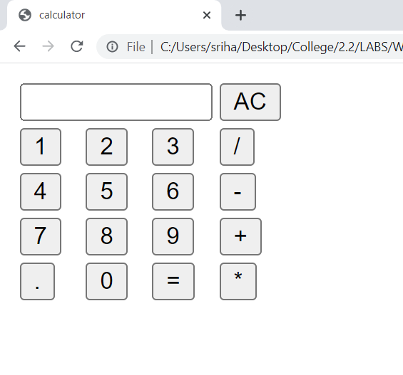

**Input given:**

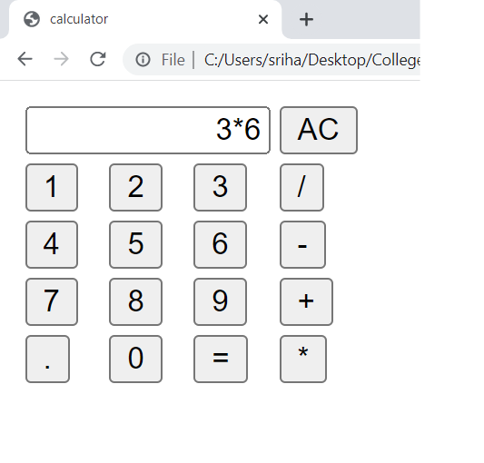

**Result:**

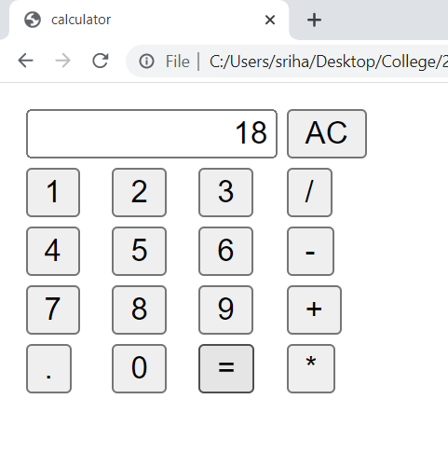

**Program-9(a) Date:23-07-2022**

**Aim: Develop and run a simple xml file.**

**Source code:**

<?xml version='1.0' encoding="UTF-8"?>

<!DOCTYPE student[

<!ELEMENT student (name,regd,address)>

<!ELEMENT name (#PCDATA)>

<!ELEMENT regd EMPTY>

<!ATTLIST regd id CDATA "401">

<!ELEMENT address (dno,city,street)>

<!ELEMENT dno (#PCDATA)>

<!ELEMENT city (#PCDATA)>

<!ELEMENT street (#PCDATA)>]>

<student>

<name>sri</name>

<regd id="507"/>

<address>

<dno>1-49</dno>

<city>Hyderabad</city>

<street>kukatpally</street>

</address>

</student>

**OUTPUT:**

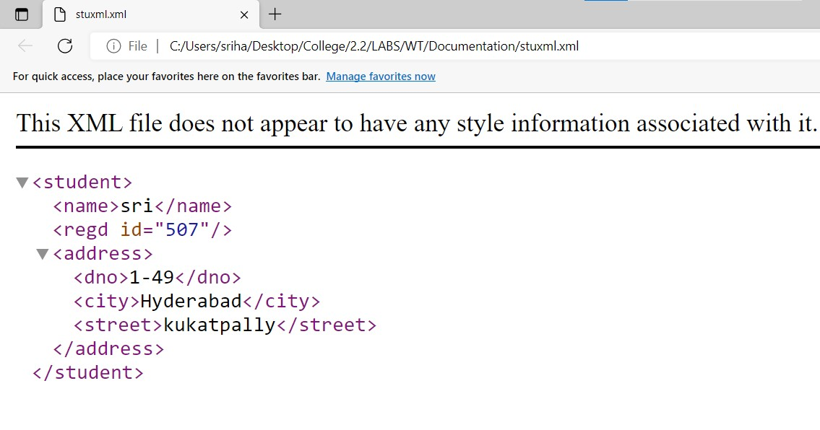

**Xml validation:**

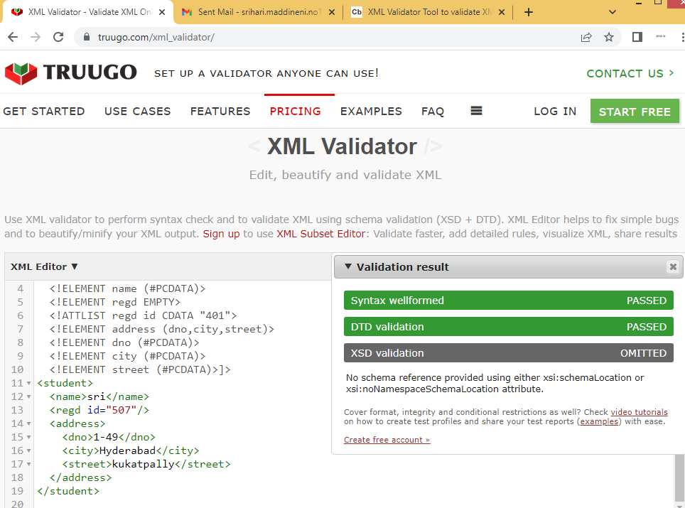

**Program-9(b) Date:23-07-2022**

**AIM: Develop a xml and external dtd file.**

**SOURCECODE:**

**External.xml:**

<?xml version="1.0" encoding="UTF-8"?>

<!DOCTYPE student SYSTEM "stu.dtd">

<student>

<name>apple</name>

<regd id="507"/>

<address>

<dno>1-49</dno>

<city>ongole</city>

<street>journalist street</street>

</address>

</student>

**stu.dtd file:**

<!ELEMENT student (name,regd,address)>

<!ELEMENT name (#PCDATA)>

<!ELEMENT regd EMPTY>

<!ATTLIST regd id CDATA "401">

<!ELEMENT address (dno,city,street)>

<!ELEMENT dno (#PCDATA)>

<!ELEMENT city (#PCDATA)>

<!ELEMENT street (#PCDATA)>

**OUTPUT:**

**Xml validation:**



**PROGRAM-10 Date:30-07-2022**

**AIM: Develop a xml and xsd files and validate them.**

**SOURCECODE:**

**Xmlfile:**

<?xml version="1.0"?>

<student branch="it">

<name>apple</name>

<regd>y20ait470</regd>

</student>

**Xsdfile:**

<?xml version="1.0"?>

<xs:schema xmlns:xs="http://www.w3.org/2001/XMLSchema">

<xs:element name="student">

<xs:complexType>

<xs:sequence>

<xs:element name="name" type="xs:string"/>

<xs:element name="regd" type="xs:string"/>

</xs:sequence>

<xs:attribute name="branch" type="xs:string"/>

</xs:complexType>

</xs:element>

</xs:schema>

**OUTPUT:**

